|  |  |
| --- | --- |
|  | **FPT ACADEMY INTERNATIONAL**  **FPT – APTECH COMPUTER EDUCATION** |

**Centre Name: ACE-HCMC-2-FPT.**

**Address: 590 Cach Mang Thang 8 street, District 3, Ho Chi Minh City, Viet Nam.**

**PET’S PARADISE**

­

|  |  |  |  |
| --- | --- | --- | --- |
| **Supervisor:** | Mr. CAT NGHIEM HIEU TUAN­ | | |
| **Semester:** | IV | | |
| **Batch No:** | T11707E0 | | |
| **Group No:** | 2 | | |
| **Order:** | **Full name** | **Roll No.** |
| **1.** | LE CONG DAT | Student1022144 |
| **2.** | TRAN THI TUYET DUYEN | Student1030933 |
| **3.** | TRAN TAN DUY | Student1053750 |

*April 2019*

|  |  |
| --- | --- |
|  |  |

Table of Contents

[REVIEW 1 3](file:///C:\Users\Elisa%20Muoi\Downloads\MysticJewel_DesignDocument_Review2_FIXED.docx#_Toc512519615)

[1. INTRODUCTION 4](file:///C:\Users\Elisa%20Muoi\Downloads\MysticJewel_DesignDocument_Review2_FIXED.docx#_Toc512519616)

[2. EXISTING SCENARIO 4](file:///C:\Users\Elisa%20Muoi\Downloads\MysticJewel_DesignDocument_Review2_FIXED.docx#_Toc512519617)

[3. CUSTOMER REQUIREMENT SPECIFICATION 5](file:///C:\Users\Elisa%20Muoi\Downloads\MysticJewel_DesignDocument_Review2_FIXED.docx#_Toc512519618)

[4. FUNCTIONAL REQUIREMENT SPECIFICATION 5](file:///C:\Users\Elisa%20Muoi\Downloads\MysticJewel_DesignDocument_Review2_FIXED.docx#_Toc512519619)

[5. SYSTEM REQUIREMENTS 15](file:///C:\Users\Elisa%20Muoi\Downloads\MysticJewel_DesignDocument_Review2_FIXED.docx#_Toc512519639)

[6. DEVELOPMENT SOFTWARE 16](file:///C:\Users\Elisa%20Muoi\Downloads\MysticJewel_DesignDocument_Review2_FIXED.docx#_Toc512519642)

[7. TECHNOLOGY 16](file:///C:\Users\Elisa%20Muoi\Downloads\MysticJewel_DesignDocument_Review2_FIXED.docx#_Toc512519643)

[REVIEW 1 – TASK SHEET 17](file:///C:\Users\Elisa%20Muoi\Downloads\MysticJewel_DesignDocument_Review2_FIXED.docx#_Toc512519644)

[REVIEW 2 18](file:///C:\Users\Elisa%20Muoi\Downloads\MysticJewel_DesignDocument_Review2_FIXED.docx#_Toc512519645)

[1. Use Case and Sequence Diagram 19](file:///C:\Users\Elisa%20Muoi\Downloads\MysticJewel_DesignDocument_Review2_FIXED.docx#_Toc512519646)

[2. Entity Relationship Diagram (ERD) 69](file:///C:\Users\Elisa%20Muoi\Downloads\MysticJewel_DesignDocument_Review2_FIXED.docx#_Toc512519675)

[3. Entity Properties 71](file:///C:\Users\Elisa%20Muoi\Downloads\MysticJewel_DesignDocument_Review2_FIXED.docx#_Toc512519678)

[4. Table Design 78](file:///C:\Users\Elisa%20Muoi\Downloads\MysticJewel_DesignDocument_Review2_FIXED.docx#_Toc512519697)

[REVIEW 2 – TASK SHEET 87](file:///C:\Users\Elisa%20Muoi\Downloads\MysticJewel_DesignDocument_Review2_FIXED.docx#_Toc512519716)

[REVIEW 3 88](file:///C:\Users\Elisa%20Muoi\Downloads\MysticJewel_DesignDocument_Review2_FIXED.docx#_Toc512519717)

[1. Site Map 89](file:///C:\Users\Elisa%20Muoi\Downloads\MysticJewel_DesignDocument_Review2_FIXED.docx#_Toc512519718)

[2. GUI Design 91](file:///C:\Users\Elisa%20Muoi\Downloads\MysticJewel_DesignDocument_Review2_FIXED.docx#_Toc512519721)

[REVIEW 3 – TASK SHEET 136](file:///C:\Users\Elisa%20Muoi\Downloads\MysticJewel_DesignDocument_Review2_FIXED.docx#_Toc512519770)

REVIEW 1

# INTRODUCTION

## Firstly, **Pet’s Paradise** is a company that is established by a club of pet lovers. They wished that they could do something to make the life of the dogs, cats or even animal which living in home better. And then Pet’s Paradise is established by the idea of place where pets can have a better life .

## **Pet’s Paradise** is a place that they that provides all of services for the pets in our home. Such as: Vet services, pet food & accessories selling, pet health caring.

## **Pet’s Paradise** has a special service called **Pet Dating**. It is an online community which is designed to bring everyone’s pet together. It is also chance for owners to meet, share favourite pet food recipes or exchange information.

# EXISTING SCENARIO

Nowaday, the quality of life is increasingly enhanced, people love animals more and express their feelings for pets more and more widely. They willing pay lots of money for their pet but they have no much time to shopping directly at store. But **Pet's Paradise** is currently just a traditional pet store, wanting expand the market with a suitable cost.

We can easily realize that the e-commerce market is growing rapidly, easily approaching the right customers. Also, **e-commerce website** will help people save time and minimize carrying cash when shopping, this helps reduce the risk of robbery when traffic is circulated, while reducing the rate of social evils also helps to build and develop the country.

Finally, **Pet's Paradise** make dicision that building a website to enter e-commerce market is a great idea.

­

# CUSTOMER REQUIREMENT SPECIFICATION

* The website must allow customers who visit the site to browse and search for products, services, partner that they want their pet to date with. Of course, that they can filter by category or sort by attribute.
* If the customer wishes to buy a product, book a service, they must register an account by mobile phone. A customer with an existing account can login. They do not have the permission to change any information apart from their own and their pet.
* Especially, a customer when registering their pet can take part in Pet Dating club. This special service can help their pet having a perfect partner, and maybe… it can help them too.
* The website must allow the admins (shop owner and others who are appointed to the job) to view, update (when requirements are met) existing products, services, categories a product’s attributes, customers who have registered, orders which have been placed
* If an admin wants to change sensitive information (e.g. delete a product, ban customers, etc.), said admin must have the authority level of a “Super Admin”, otherwise they are not going to be able to access these functions.
* Aside from managing products, categories, orders, etc. an admin can also view reports on products, orders and customers.

# FUNCTIONAL REQUIREMENT SPECIFICATION

1. User can Register

|  |  |
| --- | --- |
| Description | Functional Requirement |
| Customers must be able to register a new account. Once they have their account, they can login and access more features. A guest, who is not logged in, can only browse website. | User must provide the information below to create an account:   * Username (must be unique) * Telephone number (must be unique) * First Name and Last Name * Email (must be unique) * Date Of Birth |

1. User can Login

|  |  |
| --- | --- |
| Description | Functional Requirement |
| After registering an account, user can login. Once they have logged in, they can modify their personal information. They can also access more feature: shopping cart | * User must already have an existing account. * User must provide Telephone number and verify code to login. |

1. Admin Can manage Customers

|  |  |
| --- | --- |
| Description | Functional Requirement |
| The site must allow admins to interact with Customer’s Accounts. When a customer has registered an account, they will show up in customer list. An admin can view a list of existing registered customers. | * Must login as an admin to interact with users * Admin can search users by Telephone number and Emails |

1. Super Admin can manage User

|  |  |
| --- | --- |
| Description | Functional Requirement |
| Super Admin can also set role to an account ( admin or user) | Super Admin can set role to accounts |

1. Admin Can Manage Service Orders

|  |  |
| --- | --- |
| Description | Functional Requirement |
| The site must allow admins to interact with Orders. When a customer places an order, it will show up in the list of orders and these orders’ details. An admin can view a list of existing orders. Orders are considered highly important data and cannot be deleted. | An Service Order will contain:   * Customer ID Name of owner. * Telephone number of owner. * Name of pet. * Breed of pet. * Age of pet. * Required service providing date.   Other requirements:   1. Order must show created date 2. Admin can search orders by telephone number |

1. Admin Can Manage Dating Orders

|  |  |
| --- | --- |
| Description | Functional Requirement |
| The site must allow admins to interact with Orders. When a customer places an order, it will show up in the list of orders and these orders’ details. An admin can view a list of existing orders. Orders are considered highly important data and cannot be deleted. | An Dating Order will contain:   * Customer ID * Name of owner. * Telephone number of owner. * Name of pet. * Breed of pet. * Age of pet. * Date/Time * Location   Other requirements:   * Order must show created date * Admin can search orders by telephone number |

1. Admin Can Manage Product Orders

|  |  |
| --- | --- |
| Description | Functional Requirement |
| The site must allow admins to interact with Orders. When a customer places an order, it will show up in the list of orders and these orders’ details. An admin can view a list of existing orders. Orders are considered highly important data and cannot be deleted. | An Product Order will contain:   * Customer ID * Shipping Name * Shipping address * Shipping date   Other requirements:   * Order must show created date * Admin can search orders by telephone number |

1. Admin can view Admin’s Log

|  |  |
| --- | --- |
| Description | Functional Requirement |
| The site must allow admins to view admin’s activities log. | Activity Log includes:   * Admin’s activity * Admin who performs the activity * Date performed |

1. User can search, filter products

|  |  |
| --- | --- |
| Description | Functional Requirement |
| User can search or filter results then adding chosen products to cart and proceeding to check out. | User do not nees to log in to use this function. |

1. User can buy products

|  |  |
| --- | --- |
| Description | Functional Requirement |
| After Customer choose products, if they wish to purchase any product, they can proceed with the order. Delivery staff will deliver products to customers within 24 hours or any date customer wish, after that, pay at home after the customer checks and is satisfied with the product. This helps customers save time shopping and peace of mind about product quality when buying online. This also helps the goods can always improve the attitude of service and customer care in a very thoughtful way in order to increase the trust and satisfaction of every customer when dealing with goods. | User must log in to use this function. User can only buy products that are still in stock. User needs to provide the information below to complete their order placement:   * Name of the receiver * Required shipping date * Shipping address |

1. Recommended Products

|  |  |
| --- | --- |
| Description | Functional Requirement |
| “Recommended products" add-on function allows to display products related to the chosen one based on what they have purchased and products are popular. It can awake customers' interest in such products, thereby increases the probability of additional sales. | User must log in to use this function and will see products they have viewed. |

1. Admin Can Manage Products

|  |  |
| --- | --- |
| Description | Functional Requirement |
| The site must allow admins to interact with products.  An admin can view a list of existing products.  Admin can add a new product and modify a product’s name, description, status, category, price, color and so on. | Must login as an admin to add or modify products  To add or modify a product, admin must provide:   * Product’s Name * Product’s Description * Product’s Images * Category which product belongs to * Price * Color   Other requirements:   * Names are unique * Category must exist * Discount must be greater than 0. * When create a new product, created date can be recorded * When modify a product, modified date can be recorded * Admin can search products by names * Admin can filter by price |

1. Super Admin Can Manage Products

|  |  |
| --- | --- |
| Description | Functional Requirement |
| When an admin is a Super Admin, they can delete any products. Super Administrators also can view product details or change product information when clicking on products. | Must login as an admin to interact  *Other requirements:*   * Can only delete products which do not belong to any wish lists. |

1. User can book services for pet

|  |  |
| --- | --- |
| Description | Functional Requirement |
| There are many services in Pet’s Paradise including: health care, pet spa, fur barber,fur dyed, x-ray and emergency. The owner can search, read details, and choose a service if they need. | Customer must log in to use this function. User can book a service for their pet. User needs to provide the information below to complete their order placement:Name of owner.Telephone number of owner.Name of pet.Breed of pet.Age of pet.Required service providing date. |

1. Admin Can Manage Services

|  |  |
| --- | --- |
| Description | Functional Requirement |
| The site must allow admins to interact with Services. An admin can view a list of existing service. Admin can add a new service and modify a service’s name, description, status. | Must login as an admin to add or modify services.To add or modify a service, admin must provide:Service Name,Service Description,Active status.Names are unique.When create a new product, created date can be recordedWhen modify a product, modified date can be recorded |

1. Super Admin Can Manage Services

|  |  |
| --- | --- |
| Description | Functional Requirement |
| When an admin is a Super Admin, they can delete service. Services chosen for deletion must not belong to any order. | Can only delete services if not belong to any order. |

1. User can search Pet by attribute

|  |  |
| --- | --- |
| Description | Functional Requirement |
| User can search pet on Pet Dating club by typing attribute | User must provide information to search:   * Gender * Breed * Age |

1. User can filter Pet by attribute

|  |  |
| --- | --- |
| Description | Functional Requirement |
| User can filter pet on Pet Dating club by clicking on attribute | User must click on attribute to filter:   * Gender * Breed * Age |

1. User can register Pet to Pet dating club

|  |  |
| --- | --- |
| Description | Functional Requirement |
| User who has pet can register their pet to Pet Dating club | User must provide information to register: • Gender   * Breed * Age * Name * Image * Ready for dating * Suggestion price for dating |

1. User can update their Pet

|  |  |
| --- | --- |
| Description | Functional Requirement |
| User can update information of their pet | User must provide information to update: • Gender   * Breed * Age * Name * Image * Ready for dating * Suggestion price for dating |

1. User can Book dating service for their Pet

|  |  |
| --- | --- |
| Description | Functional Requirement |
| User who has pet can book dating service on specific pet which show on Pet Dating club and wait for accept | User must click on Pet image and provide information to Book service:   * Date/time * Location |

1. Admin can manage Pet Dating club

|  |  |
| --- | --- |
| Description | Functional Requirement |
| The site must allow admins to interact with Pet Dating club. An admin can view a list of existing pet, insert a new pet, they can also modify pet information that belong to their shop. When an admin is a Super Admin, they can delete pet. Pet chosen for deletion must not been in any dating. | To add or modify a pet, admin must provide:   1. Gender 2. Breed 3. Age 4. Name 5. Image 6. Ready for dating 7. Suggestion price for dating Other requirements: 8. Must login as an admin to add or modify pet 9. Must be a Super Admin to delete pet 10. Can only delete pet that not been in any dating 11. When create a new pet, created date can be recorded 12. When modify a pet, modified date can be recorded |

# SYSTEM REQUIREMENTS

## **Hardware**

|  |  |  |
| --- | --- | --- |
|  | SERVER | |
| Minimum | Recommended |
| Processor | 800 MHz Intel Pentium III | 2.6 GHz Intel Pentium IV |
| Memory | 2 GB | 4 GB |
| Disk space | 8 GB | 16 GB |
| Monitor | Super-VGA (800x600) or higher resolution monitor | |
| Internet | Internet access is required | |
|  | CLIENT | |
| Processor | 800 MHz Intel Pentium III | |
| Memory | 512 MB | |
| Monitor | Super-VGA (800x600) or higher resolution monitor | |
| Internet | Internet access is required | |

## **Software**

|  |  |
| --- | --- |
|  | SERVER |
| Operating System | Windows XP or later |
| Browser | Google Chrome 65.0 |
| Database | Microsoft SQL Server 2014 |
| Software | Java SDK 1.8 |
| GlassFish Server 4.0 |
|  | CLIENT |
| Operating System | Windows XP or later |
| Browser | Google Chrome 65.0 |

# DEVELOPMENT SOFTWARE

* Microsoft Windows 10
* Java SDK 1.8
* Netbeans IDE 7.4
* GlassFish Server 4.0
* Microsoft SQL Server 2016
* Google Chrome 65.0

# TECHNOLOGY

* J2EE
* JSP, Servlet
* EJB
* HTML/CSS
* JavaScript
* Apache Tiles Framework

REVIEW 1 – TASK SHEET

|  |  |  |  |  |
| --- | --- | --- | --- | --- |
| **No.** | **Contents** | **Member** | **Activity Plan** | **Preparation** |
| **Start Date** | **Status** |
| 1 | Introduction | Tran Tan Duy | 08/04/2019 | Completed |
| 2 | Existing Scenario | Tran Thi Tuyet Duyen |
| 3 | Customer Requirement Specification | Le Cong Dat |
| 4 | Functional Requirement Specification   1. Service 2. Product 3. Dating | All members:   1. Tran Tan Duy 2. Tran Thi Tuyet Duyen 3. Le Cong Dat |
| 5 | System Requirements | Tran Tan Duy |
| 6 | Development Software | Tran Thi Tuyet Duyen |
| 7 | Technology | Le Cong Dat |

Plan prepared by: Group 2 April 15th, 2019  
 **Group Leader Faculty**

**Tran Thi Tuyet Duyen Mr. Cat Nghiem Hieu Tuan**

REVIEW 2

# Use Case and Sequence Diagram

* + - 1. **User**

**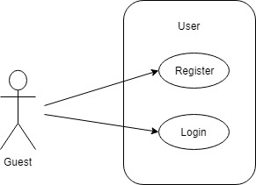**

* + - * 1. **Register as Customer**

|  |  |  |
| --- | --- | --- |
| **Author** | Tran Tan Duy | |
| **Use Case Name** | Register as Customer | |
| **Actors** | Guest | |
| **Description** | Guest registers an account on the website and becomes a member (customer) | |
| **Requirements** | Guest provides their register information | |
| **Pre-conditions** | N/A | |
| **Post-conditions** | Success: Guest creates a Customer account in this website | |
| Fail: Refill information | |
| **Basic flow** | Actor’s actions: | System’s responses: |
|  | 1. Actor clicks ‘Register’ link on Home Page.  3. Actor inputs register information and click ‘Register’ button. | 2. System redirects to Register page and displays Registration form with the following controls:  - ‘Telephone number’ text field  - ‘Username’ text field  - ‘Password’ text field  - ‘Confirm Password’ text field  - ‘First Name’ text field  - ‘Last Name’ text field  - ‘Email’ text field  - ‘Register’ button  - ‘Reset’ button  4. System validates the information.  5. System inserts the account into database  6. System show success message. |
| **Exceptions** | Actor’s actions: | System’s responses: |
| - Actor left ‘Username’ text field blank.  - Username has already existed.  - Telephone has already existed  - Actor left ‘Password’ text field blank.  -Confirm password not match the password  - Actor left ‘Name’ text field blank.  - Actor left ‘Birthday’ field blank.  - Input age is less than 16.  - Actor left ‘Phone’ text field blank.  - Input phone is not numeric format or phone length is not between 8 and 14 characters.  - Actor left ‘Email’ text field blank or input an invalid email address. | - ‘Username cannot be blank’.  - ‘This username has already existed’.  - ‘This telephone has already existed’.  - ‘Password cannot be blank’’.  - ‘Confirm Password does not match password.’  - ‘Name cannot be blank’.  - ‘Birthday is invalid’.  - ‘Age must be over 16’.  - ‘Phone is invalid’.  - ‘The phone number should be numeric only and must be between 8 and 14 digits’.  - ‘Email is invalid’. |

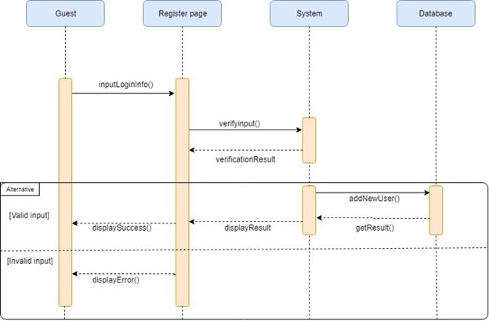

* 1. Login

|  |  |  |
| --- | --- | --- |
| **Author** | Tran Tan Duy | |
| **Use Case Name** | Login | |
| **Actors** | Customer | |
| **Description** | Customer who has registered an account can login | |
| **Requirements** | Actor provides Telephone number and verify code | |
| **Pre-conditions** | Actor must register an account | |
| **Post-conditions** | Success: User is logged in to website | |
| Fail: Refill information | |
| **Basic flow** | **Actor’s actions:** | **System’s responses:** |
| 1. Actor clicks on ‘Login’ button.  3. Actor inputs telephone number and click ‘Login’ button 6. Actor inputs verify code and click ‘Login’ button | 2. System redirects to Login Page with the following controls - ‘Telephone number’text field - 'Login' button  4. System send verify code to the telephone number of user.  5. System refresh Login Page with the following controls - ‘Verify Code’ text field  - 'Login' button 7. System checks the information. 8. System redirects to User’s dashboard. |
|
|
| **Exceptions** | **Actor’s actions:** | **System’s responses:** |
| - Actor inputs invalid telephone number  -Actor inputs invalid verify code | -“This telephone number hasn’t been registered”  -”Invalid verify code, please try again” |

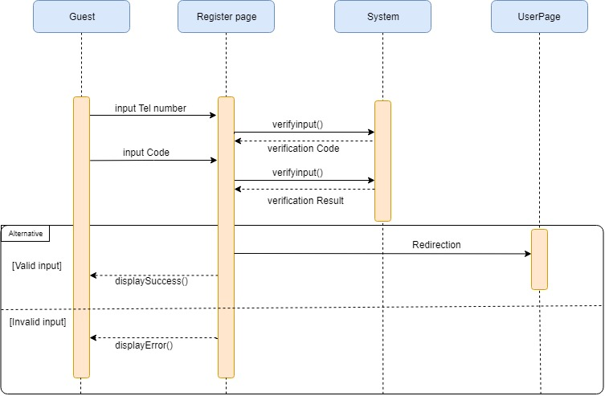

1. **Product**

**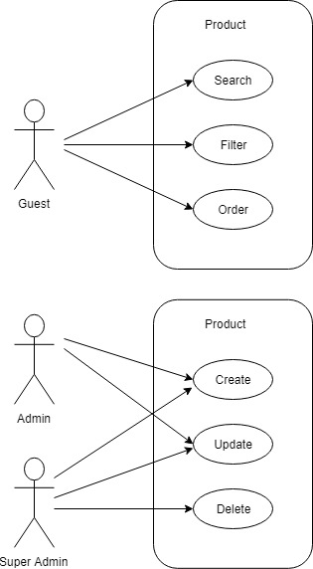**

****

### **Search Products**

|  |  |  |
| --- | --- | --- |
| **Author** | Tran Thi Tuyet Duyen | |
| **Use Case Name** | Search products by name | |
| **Actors** | Guest/Customer | |
| **Description** | Guest/Customer wants to look for products by name | |
| **Requirements** | Actor provides search phrase | |
| **Pre-conditions** | N/A | |
| **Post-conditions** | Success: Show products that matches search phrase | |
| Fail: No product is shown and inform user | |
| **Basic flow** | **Actor’s actions:** | **System’s responses:** |
| 1. Actor inputs search phrase.  3. Actor clicks product’s name in list or view every product that matches search phrase. | 2. System show list of products that match the search phrase.  4. System allows actor to sort products by:  - Lowest Price  - Highest Price |
|
|
|
|
|
|
|
|

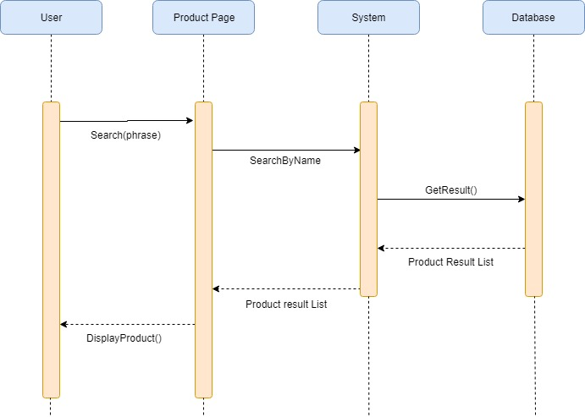

b.Filter Products

|  |  |  |
| --- | --- | --- |
| **Author** | Tran Thi Tuyet Duyen | |
| **Use Case Name** | Product Filter | |
| **Actors** | Guest/Customer | |
| **Description** | Guest/Customer wants to filter products by conditions | |
| **Requirements** | Actor chooses conditions by ticking checkboxes | |
| **Pre-conditions** | N/A | |
| **Post-conditions** | Success: Products that matches condition(s) are shown | |
| Fail: No product is shown and inform actor | |
| **Basic flow** | **Actor’s actions:** | **System’s responses:** |
| 1. Actor ticks one or multiple of the following checkboxes:  - Categories  - Price | 2. System show products that satisfy the condition(s)  3. System allows actor to sort products by:  - Lowest Price  - Highest Price |

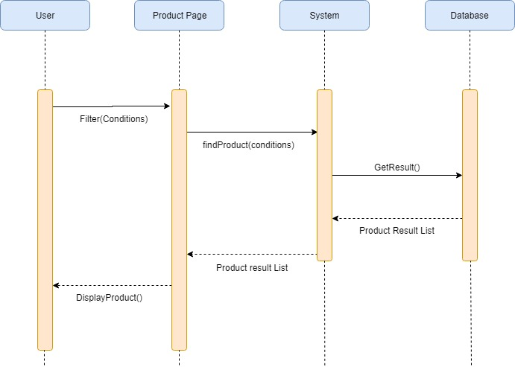

* 1. Order Product

|  |  |  |
| --- | --- | --- |
| **Author** | Tran Thi Tuyet Duyen | |
| **Use Case Name** | Check and Order | |
| **Actors** | Guest/Customer | |
| **Description** | Guest/Customer wants to order products | |
| **Requirements** | Actor must choose at least one product to add to cart | |
| **Pre-conditions** | Cart has at least one product | |
| **Post-conditions** | Success: Actor order successfully | |
| Fail: Refill information | |
| **Basic flow** | **Actor’s actions:** | **System’s responses:** |
| 1. Actor chooses a product and click ‘Add to Cart’ button.  3. Actor clicks ‘Check’ button.    8. Actor inputs order’s information, then click ‘Order’ button.  11. Actor views order’s status in Order Page. | 2. System adds product to cart by ProID.  4. System shows Cart and added products. 5. System verifies voucher code.  6. System shows all products in cart and calculate unit price.  7. System redirects to Order Information page and show the following controls:  - ‘Billing Name’ text field  - ‘Address’ text field  - ‘Required date’  9. System validates information.  10. System redirects to Order page and shows order’s status. |
|
|
|
|
|
|
|
|
| **Alternative flow** | 1. Actor clicks ‘Go back to shopping’  3. Actor clicks ‘X’ button on each product. | 2. System redirects to product page.  4. System removes product from cart. |
| **Exceptions** | **Actor’s actions:** | **System’s responses:** |
| 1. Actor inputs more products than there are in stock.  2. Actor left ‘Billing Name’ text field blank.  3. Actor left ‘Address’ text field blank. | System shows messages:  - ‘Product out of stock’  - ‘Billing name must not be blank’  - ‘Address must not be blank’ |

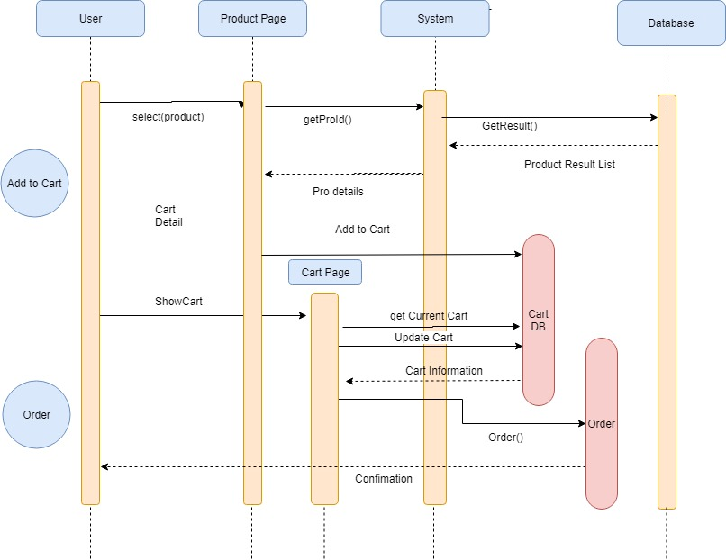

* 1. Create new Product

|  |  |  |
| --- | --- | --- |
| **Author** | Tran Thi Tuyet Duyen | |
| **Use case name** | Create New Product (with SKUs and Images) | |
| **Actors** | Administrator | |
| **Description** | When admin wants to create a new product | |
| **Requirements** | Actor provides product’s information | |
| **Pre-conditions** | Actor is logged in as admin or super admin | |
| **Post-conditions** | Success: new product with SKUs and images is added into the database | |
| Fail: refill information | |
| **Basic flow** | **Actor’s actions:** | **System’s responses:** |
| 1. Actor chooses Product Tab on menu.  3. Actor clicks ‘Add New Product’ button.  5. Actor inputs information to create product. | 2. System redirects to ‘Product’ page and display a list of existing products.  4. System displays a form with the following fields. - Product’s Name  - Product’s Description  - Category  - Price  6. System validates inputs.  7. System adds product into database.  8. System displays a form for adding Products and Images for this product.  9. System displays confirmation message or error message. |
|
|
|
|
|
|
|
|
|
| **Exceptions** | **Actor’s actions:** | **System’s responses:** |
| 1. Actor left ‘Product Name’ blank.  2. Actor left ‘Product Description’ blank.  3. Actor does not choose a Category.  5. Actor does not add any Product  6. Actor does not add any Image  7. Actor does not add price  8. Product ID existed in database | System displays messages:  ­­- ‘Product Name cannot be blank’  - ‘Description cannot be blank’  - ‘Must choose a Category’  - ‘Product must have Product and Image’  - ‘Product ID must be unique’  - ‘Product must have price’ |
|
|

**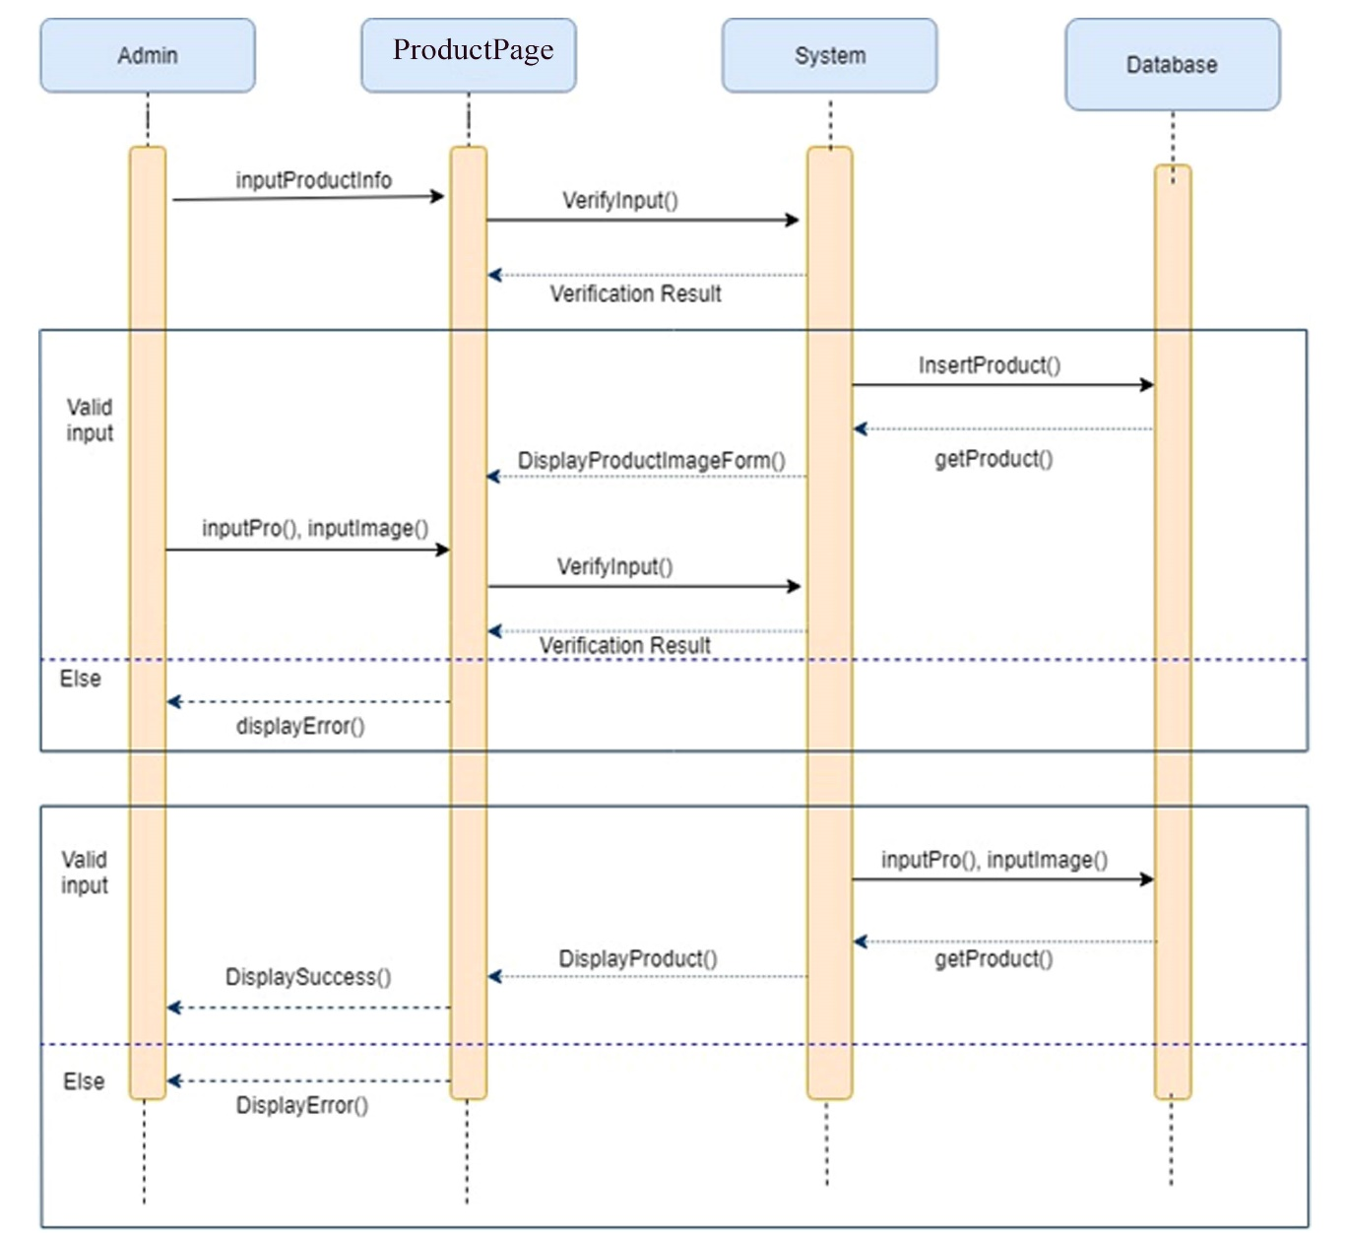**

* 1. Update product

|  |  |  |
| --- | --- | --- |
| **Author** | Tran Thi Tuyet Duyen | |
| **Use case name** | Update product’s details | |
| **Actors** | Administrator | |
| **Description** | When admin wants to update product’s details | |
| **Requirements** | Actor provides product’s information | |
| **Pre-conditions** | Actor is logged in as admin or super admin | |
| **Post-conditions** | Success: product is updated in the database | |
| Fail: refill information | |
| **Basic flow** | **Actor’s actions:** | **System’s responses:** |
| 1. Actor chooses Product Tab on menu.  3. Actor clicks on ‘View Details’ on a product.  5. Actor chooses the infor they want to update and input information. | 2. System redirects to ‘Product Details’ page and displays a list of existing products.  4. System displays product’s detail where actor can update the following information: - Product’s Name  - Product’s Description  - Category  - update Price  - update Images  6. System validates inputs.  7. System updates product in the database.  8. System displays confirmation message or error message.  9. System redirects to product’s detail page. |
|
|
|
|
|
|
|
|
|
| **Exceptions** | **Actor’s actions:** | **System’s responses:** |
| 1. Actor left ‘Product Name’ blank.  2. Actor left ‘Product Description’ blank.  3. Actor does not choose a Category.  4. Actor does not choose a Category.  5. Product ID existed in database | System displays messages: - ‘Product Name cannot be blank’  - ‘Description cannot be blank’  - ‘Must choose a Category’  - ‘must have price’  - ‘Product ID must be unique’ |
|
|

**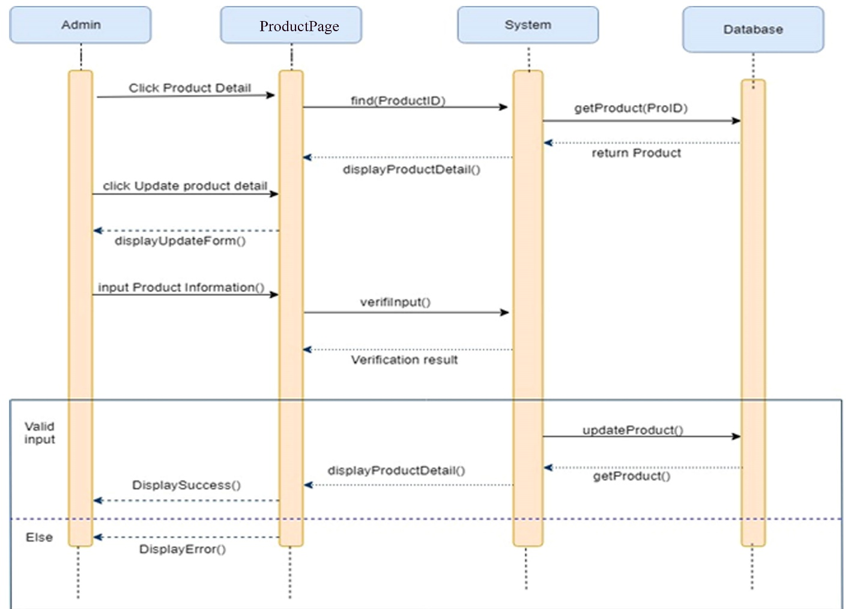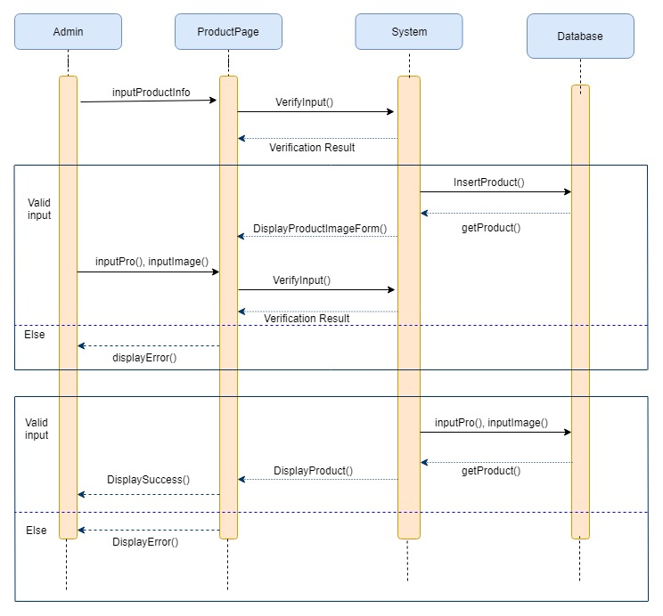**

* 1. Delete Product

|  |  |  |
| --- | --- | --- |
| **Author** | Tran Thi Tuyet Duyen | |
| **Use case name** | Delete Product | |
| **Actors** | Super admin | |
| **Description** | When super admin wants to delete a product from the database | |
| **Requirements** | Actor provides product’s information | |
| **Pre-conditions** | Actor is logged in as super admin | |
| **Post-conditions** | Success: product is deleted from the database | |
| Fail: product is not deleted from the database | |
| **Basic flow** | **Actor’s actions:** | **System’s responses:** |
| 1. Actor chooses Product Tab on menu.  3. Actor clicks ‘Product Detail’ button.  5. Actor clicks ‘Delete’ in Product List and clicks confirm. | 2. System redirects to 'Product List' page and displays a list of existing products.  4. System displays Product’s detail page.  6. System validates inputs.  7. System deletes product in the database.  8. System displays confirmation or error. |

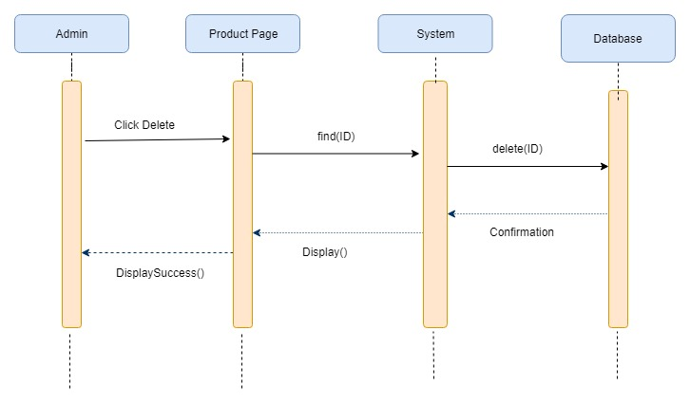

1. **Create Category:**

**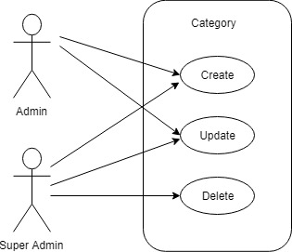**

### **Create Category**

|  |  |  |
| --- | --- | --- |
| **Author** | Tran Thi Tuyet Duyen | |
| **Use case name** | Add product’s categories | |
| **Actors** | Administrator | |
| **Description** | When admin wants to add a new category in the database | |
| **Requirements** | Actor provides category’s information | |
| **Pre-conditions** | Actor is logged in as admin or super admin | |
| **Post-conditions** | Success: category is added in the database | |
| Fail: refill information | |
| **Basic flow** | **Actor’s actions:** | **System’s responses:** |
| 1. Actor chooses Category Tab on menu.  3. Actor clicks ‘Add New Category’.  5. Actor inputs information to create category. | 2. System redirects to 'Category List' page and display a list of existing categories.  4. System displays a form with the following fields: Category’s Name & Parent category  6. System validates inputs.  7. System add category into database.  8. System displays confirmation message or error message. |
| **Exceptions** | **Actor’s actions:** | **System’s responses:** |
| 1. Actor left ‘Category’s Name’ field blank.  2. Category’s Name existed in database. | System displays messages: - ‘Category’s Name cannot be blank’. - ‘Category’s Name must be unique’. |
|
|

**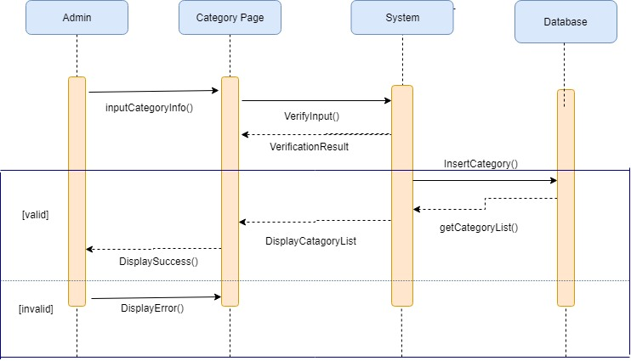**

### **Update category**

|  |  |  |
| --- | --- | --- |
| **Author** | Tran Thi Tuyet Duyen | |
| **Use case name** | Update category | |
| **Actors** | Administrator | |
| **Description** | When admin wants to update a category | |
| **Requirements** | Actor provides category’s information | |
| **Pre-conditions** | Actor is logged in as admin or super admin | |
| **Post-conditions** | Success: category is updated in the database | |
| Fail: refill information | |
| **Basic flow** | **Actor’s actions:** | **System’s responses:** |
| 1. Actor chooses Category Tab on menu.  3. Actor clicks “Update” on Category list.  5. Actor inputs information update Category. | 2. System redirects to 'Category List' page and display a list of existing categories.  4. System displays a form with the following fields. - Category’s Name - Parent category (optional)  6. System validates inputs.  7. System updates category in database  8. System displays confirmation message or error message. |
| **Exceptions** | **Actor’s actions:** | **System’s responses:** |
| 1. Actor left ‘Category’s Name’ field blank.  2. Category’s Name existed in database. | System displays messages: - ‘Category’s Name cannot be blank’. - ‘Category’s Name must be unique’. |
|
|

**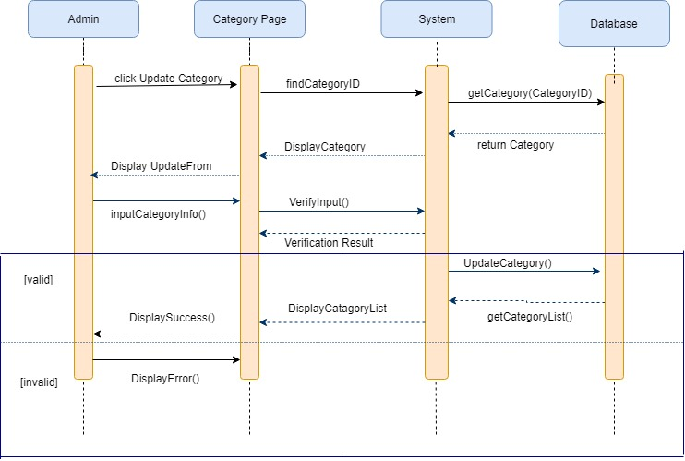**

### **Delete category**

|  |  |  |
| --- | --- | --- |
| **Author** | Tran Thi Tuyet Duyen | |
| **Use case name** | Delete category | |
| **Actors** | Super Admin | |
| **Description** | When a super admin wants to delete a category from the database | |
| **Requirements** | Actor provides category’s information | |
| **Pre-conditions** | Actor is logged in as super admin | |
| **Post-conditions** | Success: category is deleted from the database | |
| Fail: category is not deleted from the database | |
| **Basic flow** | **Actor’s actions:** | **System’s responses:** |
| 1. Actor chooses Category Tab on menu.  3. Actor clicks on ‘Delete’ button and confirm. | 2. System redirects to 'Category List' page and display a list of existing categories.  4. System delete category from database.  5. System displays confirmation message or error message. |

**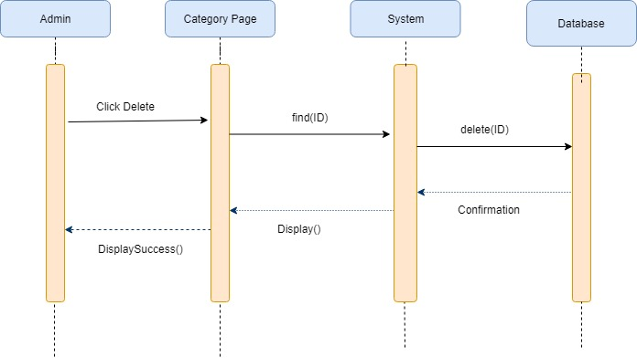**

****

1. **Service**

**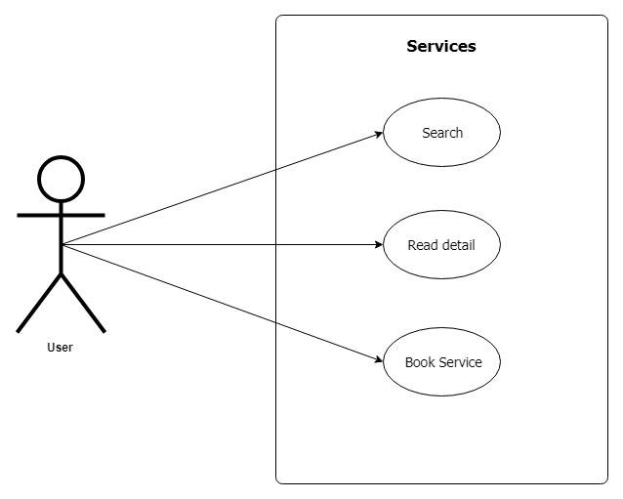**

**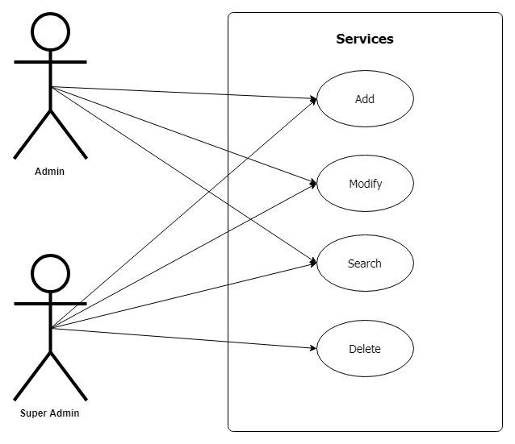**

* 1. **Service search**

|  |  |  |
| --- | --- | --- |
| **Author** | Tran Tan Duy | |
| **Use Case Name** | Search services by relative name | |
| **Actors** | Customer | |
| **Description** | Customer wants to search for services by name | |
| **Requirements** | Actor provides search phrase | |
| **Pre-conditions** | N/A | |
| **Post-conditions** | Success: Show services that matches search phrase | |
| Fail: No service is shown | |
| **Basic flow** | **Actor’s actions:** | **System’s responses:** |
| 1. Actor inputs search phrase.  3. Actor click service’s name in list or view every service that matches search phrase. | 2. System show list of services that match the search phrase. |

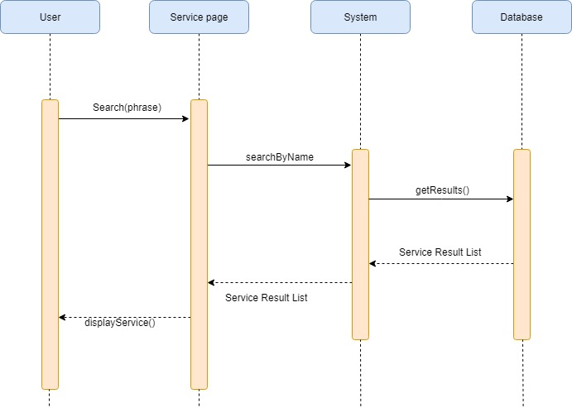

* 1. **Book Service**

|  |  |  |
| --- | --- | --- |
| **Author** | Tran Tan Duy | |
| **Use Case Name** | Place Order | |
| **Actors** | Customer | |
| **Description** | Customer wants to book a service for pet | |
| **Requirements** | Actor has to choose a service | |
| **Pre-conditions** |  | |
| **Post-conditions** | Success: Actor book successfully | |
| Fail: Refill information | |
| **Basic flow** | **Actor’s actions:** | **System’s responses:** |
| 1. Actor chooses a service and click ‘Book service’ button.    3. Actor inputs order information,they can be auto filled if owner has already registered their pet. then click ‘Place Order’ button.  6. Actor views order’s status in Order Page. | 2. System redirects to Service Booking Information page and show the following controls:  - ‘Owner name’ text field.  - ‘Pet name’ text field.  - ‘Pet age’ text field.  - ‘Pet breed’ text field.  - ‘Telephone number’ text field.  - ‘Required date’ datetime field.  4. System validates information.  5. System redirects to Order page and shows order’s status. |
|
|
|
|
|
|
|
|
| **Alternative flow** | 1. Actor clicks ‘Go back to service page’ | 2. System redirects to service page. |
| **Exceptions** | **Actor’s actions:** | **System’s responses:** |
| 1. Actor left ‘Owner name’ text field blank.  2. Actor left ‘Pet name’ text field blank.  3. Actor left ‘Pet age’ text field blank.  4. Actor left ‘Pet breed’ text field blank.  5. Actor left ‘Telephone number’ text field blank.  6. Actor left ‘Required date’ datetime field blank. | System shows messages:  - ‘Owner name must not be blank’  - ‘Pet name must not be blank’  - ‘Pet age must not be blank’  - ‘Pet breed must not be blank’  - ‘Telephone number  must not be blank’  - ‘Must choose a required date’ |

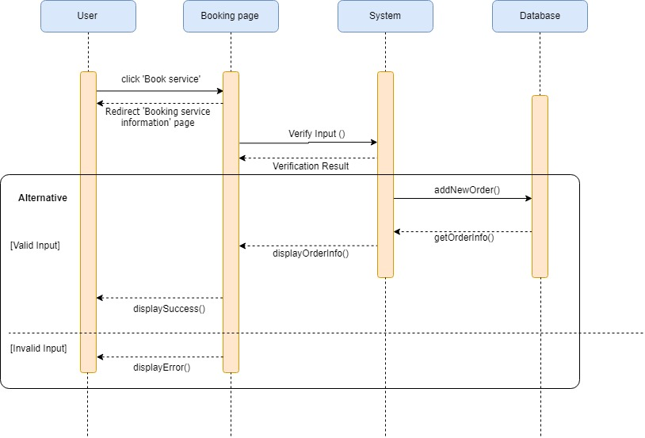

* 1. **Add a service**

|  |  |  |
| --- | --- | --- |
| **Author** | Tran Tan Duy | |
| **Use case name** | Add New Service | |
| **Actors** | Administrator | |
| **Description** | When admin wants to create a new service | |
| **Requirements** | Actor provides service information | |
| **Pre-conditions** | Actor is logged in as admin or super admin | |
| **Post-conditions** | Success: new service  is added into the database | |
| Fail: refill information | |
| **Basic flow** | **Actor’s actions:** | **System’s responses:** |
|  | 1. Actor chooses Service Tab on menu.  3. Actor clicks ‘Add New Service’ button.    5. Actor inputs information to create product. | 2. System redirects to ‘Service’ page and display a list of existing services.  4. System displays a form with the following fields. - Service Name  - Service Description  6. System validates inputs.  7. System adds service into database.  8. System displays confirmation message or error message. |
| **Exceptions** | **Actor’s actions:** | **System’s responses:** |
| 1. Actor left ‘Service Name’ blank.  2. Actor left ‘Service Description’ blank.  3. Service name existed in database | System displays messages: - ‘Service Name cannot be blank’  - ‘Description cannot be blank’  - ‘Service name is existing in Database’ |
|
|

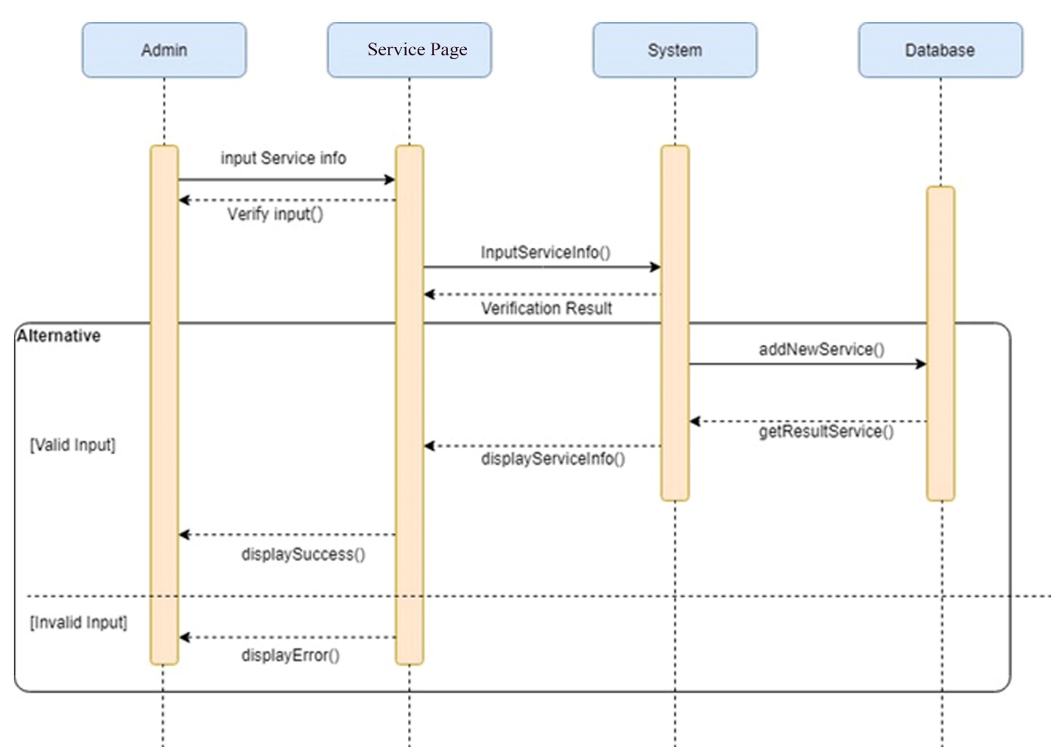

* 1. **Modify a service**

|  |  |  |
| --- | --- | --- |
| **Author** | Tran Tan Duy | |
| **Use case name** | Update service details | |
| **Actors** | Administrator | |
| **Description** | When admin wants to update service details | |
| **Requirements** | Actor provides service information | |
| **Pre-conditions** | Actor is logged in as admin or super admin | |
| **Post-conditions** | Success: Service is updated in the database | |
| Fail: refill information | |
| **Basic flow** | **Actor’s actions:** | **System’s responses:** |
| 1. Actor chooses Service Tab on menu.  3. Actor clicks on ‘View Details’ on a product.  5.Actor edit the field that he want to modify. | 2. System redirects to ‘Service’ page and displays a list of existing services.  4. System displays service detail where actor can update the following information: - Service Name  - ServiceDescription  6. System validates inputs.  7. System updates product in the database.  8. System displays confirmation message or error message.  9. System redirects to ‘Service’ page. |
|
|
|
|
|
|
|
|
|
| **Exceptions** | **Actor’s actions:** | **System’s responses:** |
| 1. Actor left ‘Sevice Name’ blank.  2. Actor left ‘Service Description’ blank.  3. Service Name has existed in database | System displays messages: - ‘Product Name cannot be blank’  - ‘Description cannot be blank’  - ‘Service name has exitsted in database’ |
|
|

**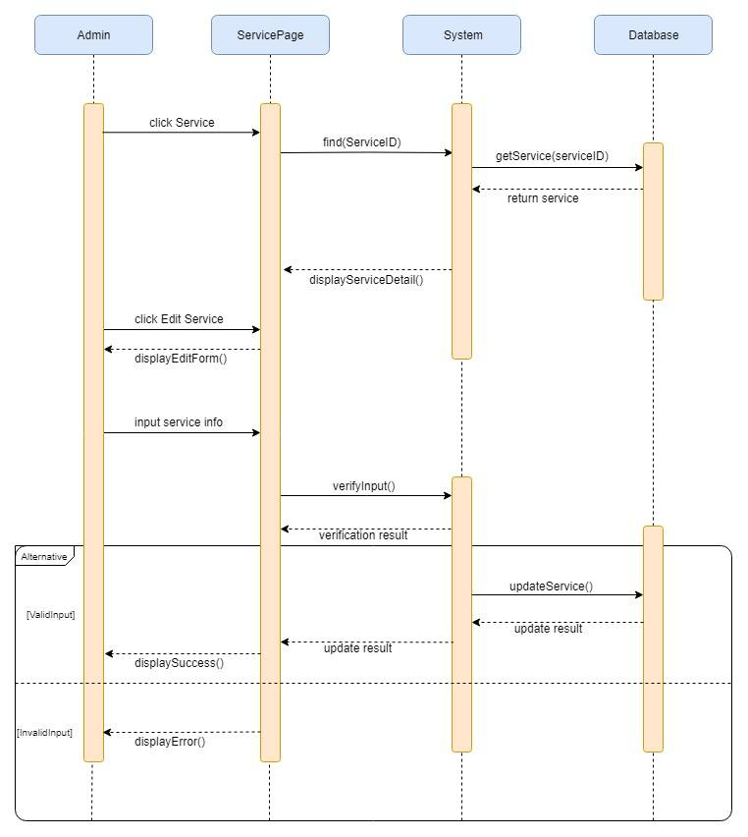**

* 1. **Delete a service**

|  |  |  |
| --- | --- | --- |
| **Author** | Tran Tan Duy | |
| **Use case name** | Delete a service | |
| **Actors** | Super Administrator | |
| **Description** | When super admin wants to delete service | |
| **Requirements** | Only super admin can delete service | |
| **Pre-conditions** | Actor is logged in as super admin | |
| **Post-conditions** | Success: Service is updated in the database | |
|  | |
| **Basic flow** | **Actor’s actions:** | **System’s responses:** |
| 1. Actor chooses Service Tab on menu.  3. Actor clicks on ‘View Details’ on a product.  5.Actor click on “Delete service” button  6.Actor click on “Yes” | 2. System redirects to ‘Service’ page and displays a list of existing services.  4. System displays service detail  7. System show a confirmation dialog  8. System delete service in the database.  9. System displays confirmation message or error message.  10. System redirects to ‘Service’ page |

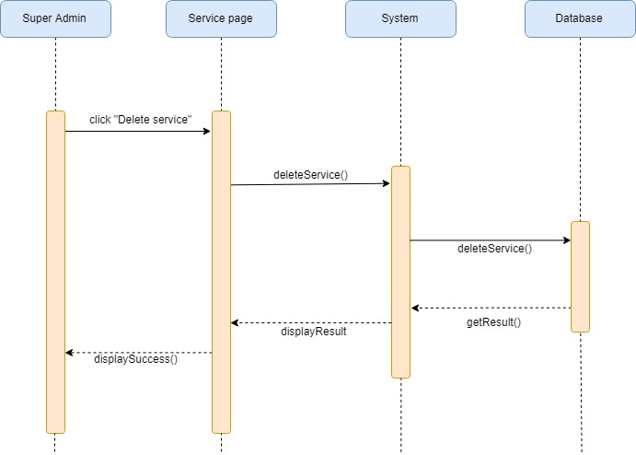

1. **Pet**

**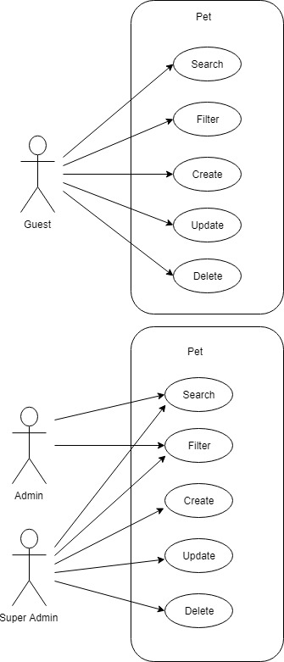**

****

* + - * 1. **Create new Pet**

|  |  |  |
| --- | --- | --- |
| **Author** | Le Cong Dat | |
| **Use case name** | Add new Pet | |
| **Actors** | Customer | |
| **Description** | When customer add new pet | |
| **Requirements** | Customer provide pet’s information | |
| **Pre-conditions** | Customer is logged in | |
| **Post-conditions** | Success: New Pet is added to database | |
| Fail: refill information | |
| **Basic flow** | **Actor’s actions:** | **System’s responses:** |
| Actor click on Add new Pet.  Actor fill in form and click ‘Add New’. | System redirects to ‘New Pet' page and display a form with the following fields.  Breed - Age - Name - Image – Gender -  Ready for dating  Suggestion price for dating  System validates inputs.  System add Pet into database.  6. System displays confirmation message or error message. |
| **Exceptions** | **Actor’s actions:** | **System’s responses:** |
| Scenario  Actor left ‘Breed’ field blank.  Actor left ‘Name’ field blank.  Actor left ‘Price’ field blank.  Actor left ‘Gender’ field blank.  Actor left ‘Image’ blank. | System displays messages: - ‘Breed cannot be blank’. - ‘Name cannot be blank’.  - ‘Price cannot be blank’.  -‘Gender cannot be blank’.  - ‘Use default image’. |

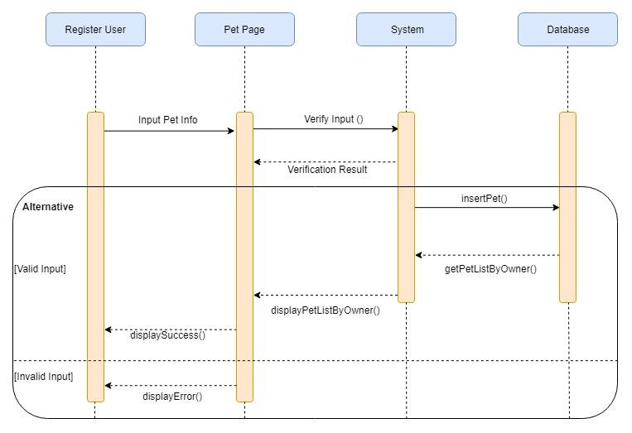

* + - * 1. **Search Pet**

|  |  |  |
| --- | --- | --- |
| **Author** | Le Cong Dat | |
| **Use case name** | Search Pet | |
| **Actors** | Customer | |
| **Description** | When customer search Pet by Breed, Gender | |
| **Requirements** | Customer provide pet’s Breed and Gender | |
| **Pre-conditions** | No special requirement | |
| **Post-conditions** | Success: List Pet return | |
| Fail: refill information | |
| **Basic flow** | **Actor’s actions:** | **System’s responses:** |
| 1.Actor fill in Breed, Gender and click Search. | 2.System validates inputs.  3.System search Pet from Database.  4. System return List of Pet. |
| **Exceptions** | **Actor’s actions:** | **System’s responses:** |
| Scenario  Actor left ‘Breed’ field blank.  Actor left ‘Gender’ field blank. | System displays messages: - ‘Breed cannot be blank’.  - ‘Gender cannot be blank’. |

­­­­­­­­

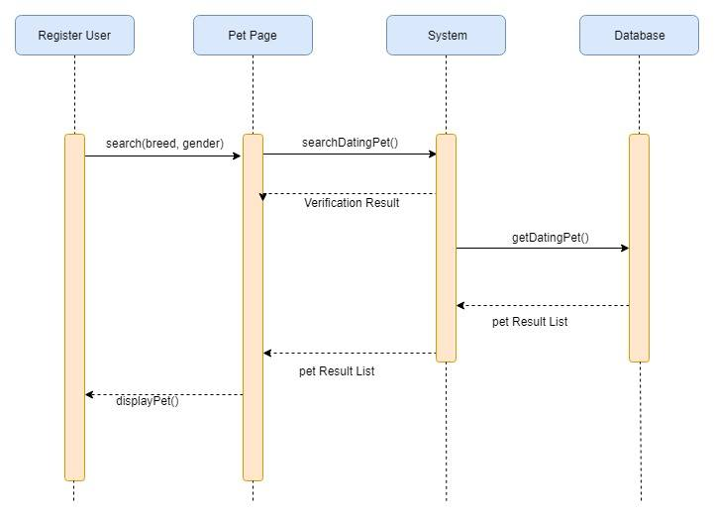

* + - * 1. **Filter Pet**

|  |  |  |
| --- | --- | --- |
| **Author** | Le Cong Dat | |
| **Use case name** | Filter Pet | |
| **Actors** | Customer | |
| **Description** | When customer filter pet list | |
| **Requirements** | Customer provide criteria to filter | |
| **Pre-conditions** | No special requirement | |
| **Post-conditions** | Success: List Pet is filtered | |
| Fail: | |
| **Basic flow** | **Actor’s actions:** | **System’s responses:** |
| Actor click on Attribute and click Filter. | System filter list of pet  3. System return list of filtered pet |
| **Exceptions** | **Actor’s actions:** | **System’s responses:** |
| 1.Actor doesn’t choose any Attribute | -Sytem show message ‘Please click on attribute you want to filter’ |

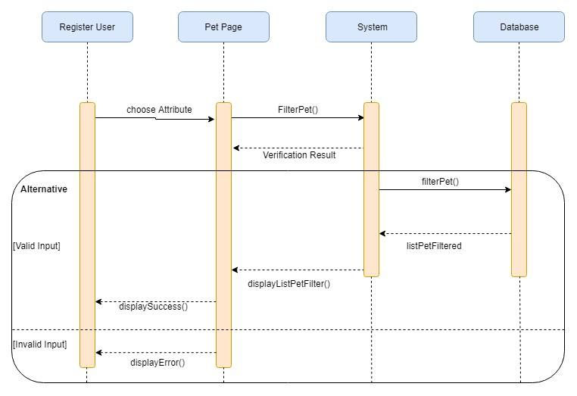

* + - * 1. **Update Pet**

|  |  |  |
| --- | --- | --- |
| **Author** | Le Cong Dat | |
| **Use case name** | Update Pet | |
| **Actors** | Customer | |
| **Description** | When customer update their pet’s information | |
| **Requirements** | Customer provide new information | |
| **Pre-conditions** | Customer is logged in | |
| **Post-conditions** | Success: New Pet ‘s information is updated into database | |
| Fail: refill information | |
| **Basic flow** | **Actor’s actions:** | **System’s responses:** |
| Actor click on their pet.  Actor fill new information in form and click ‘Save Change’. | System redirects to ‘Pet Detail’ page and display a form with the following fields and current information.  Breed - Age - Name - Image - Gender -  Ready for dating - Suggestion price for dating - System validates inputs.  System update new information into database.  6. System displays confirmation message or error message. |
| **Exceptions** | **Actor’s actions:** | **System’s responses:** |
| Scenario  Actor left ‘Breed’ field blank.  Actor left ‘Name’ field blank.  Actor left ‘Price’ field blank.  Actor left ‘Gender’ field blank.  Actor left ‘Image’ blank. | System displays messages: - ‘Breed cannot be blank’. - ‘Name cannot be blank’.  ‘Price cannot be blank’.  ‘Gender cannot be blank’.  - ‘Use default image’. |

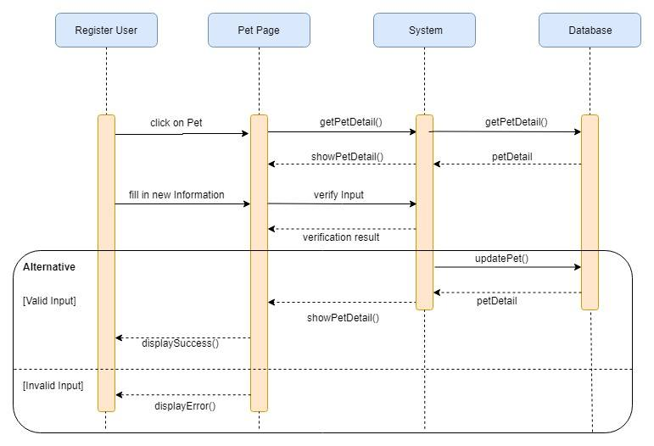

* + - * 1. **Delete Pet**

|  |  |  |
| --- | --- | --- |
| **Author** | Le Cong Dat | |
| **Use case name** | Delete Pet | |
| **Actors** | Customer | |
| **Description** | When customer delete their own pet, or super admin delete shop’s pet | |
| **Requirements** | Provide Pet’s information | |
| **Pre-conditions** | Logged in | |
| **Post-conditions** | Success: selected Pet is deleted from database | |
| Fail: choose Pet again | |
| **Basic flow** | **Actor’s actions:** | **System’s responses:** |
| Actor choose their Pet  3.Actor click on ‘Delete’ button | System redirect to ‘Pet Detail’ page and show current information.  3.System delete Pet from database  4. System display confirmation message or error message |

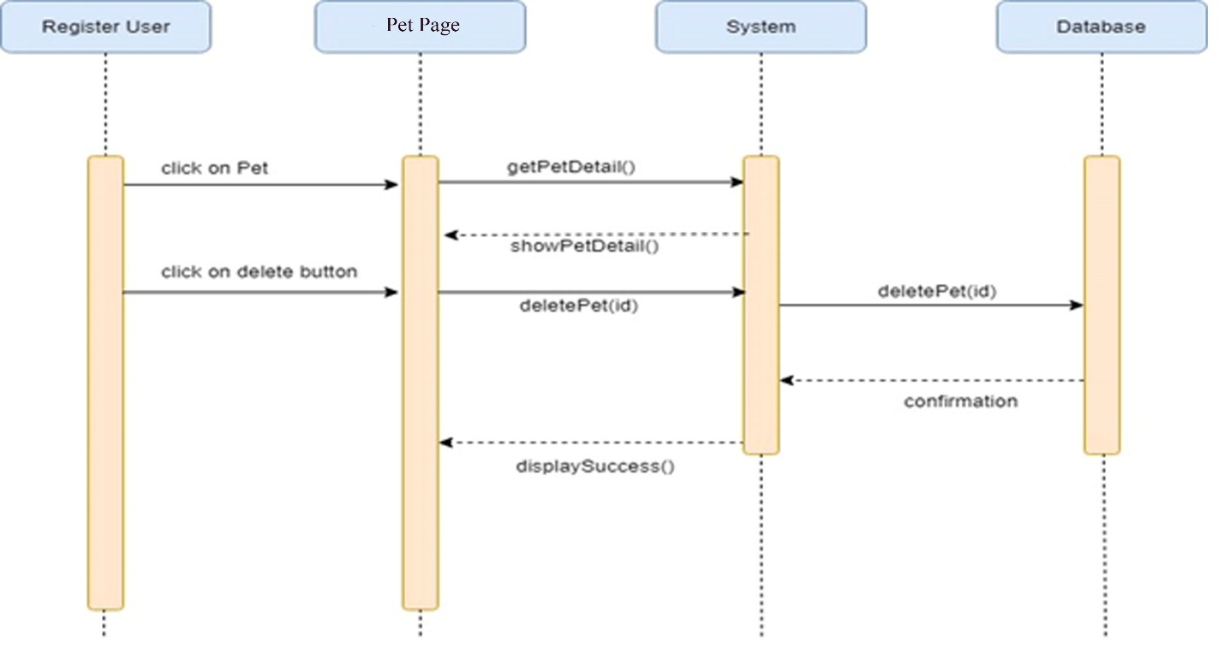

1. **Pet Dating**

**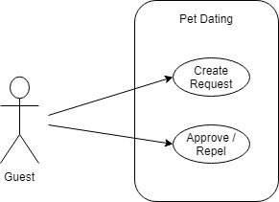**

* 1. **Create Pet Dating Request**

|  |  |  |
| --- | --- | --- |
| **Author** | Le Cong Dat | |
| **Use case name** | Create Pet Dating request | |
| **Actors** | Customer | |
| **Description** | When customer want their pet dating with another pet | |
| **Requirements** | Customer provide information about Time and Location for dating | |
| **Pre-conditions** | Customer is logged in | |
| **Post-conditions** | Success: Pet Dating request is saved in database | |
| Fail: refill information | |
| **Basic flow** | **Actor’s actions:** | **System’s responses:** |
| Actor click on Pet Dating Button  Actor fill new information in form and click ‘Request’. | System redirects to ‘Pet Dating Detail’ page and display Pet Detail and a form with the following fields.  Date/Time  Location  System validates inputs.  System update new Dating request into database.  6. System displays confirmation message or error message. |
| **Exceptions** | **Actor’s actions:** | **System’s responses:** |
| Scenario  Actor left ‘Date/Time’ field blank.  Actor left ‘Location’ field blank. | System displays messages: - ‘Date/Time cannot be blank’. - ‘Location cannot be blank’. |

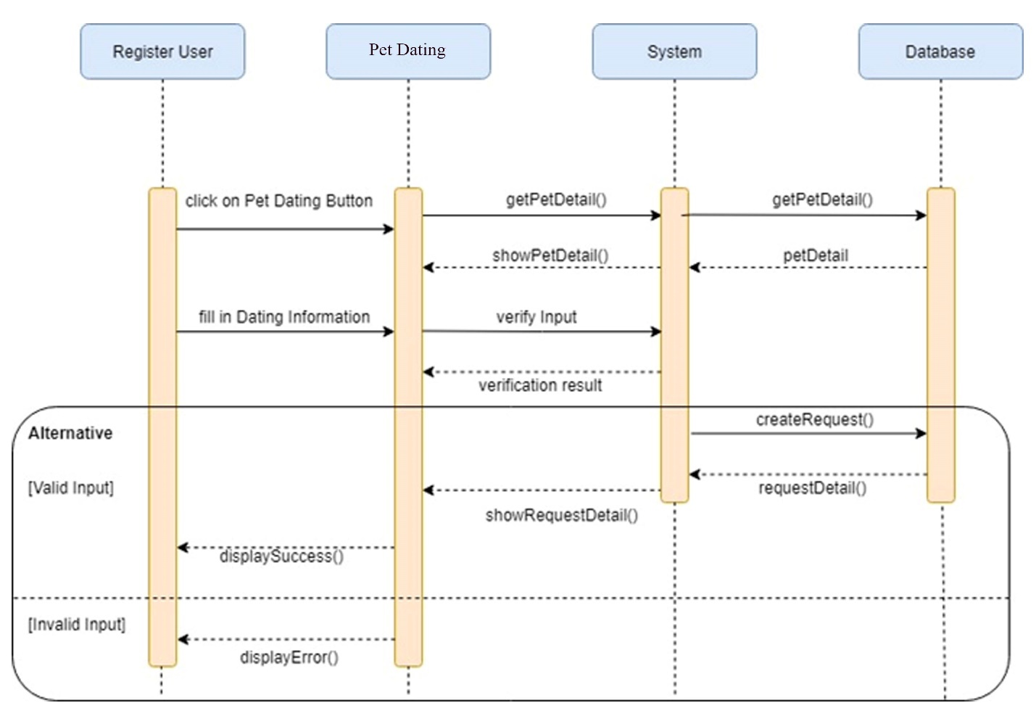

* 1. **Approve/Repel Pet Dating Request**

|  |  |  |
| --- | --- | --- |
| **Author** | Le Cong Dat | |
| **Use case name** | Approve/Repel Pet dating request | |
| **Actors** | Customer | |
| **Description** | When customer want approve or repel a request from another customer | |
| **Requirements** | No special requirement | |
| **Pre-conditions** | Customer is logged in | |
| **Post-conditions** | Success: Pet Dating request status is updated into database | |
| Fail: | |
| **Basic flow** | **Actor’s actions:** | **System’s responses:** |
| 1.Actor click on My Pet Dating menu  3.Actor choose on specific Pet Dating plan.  5.Actor choose Approve or Repel | 2.System redirects to ‘Pet Dating’ list page  4.System redirects to ‘Pet Dating Detail’ page and display Pet detail and dating information  -Date/Time  -Location  System update Dating request status into database.  6. System displays confirmation message or error message. |

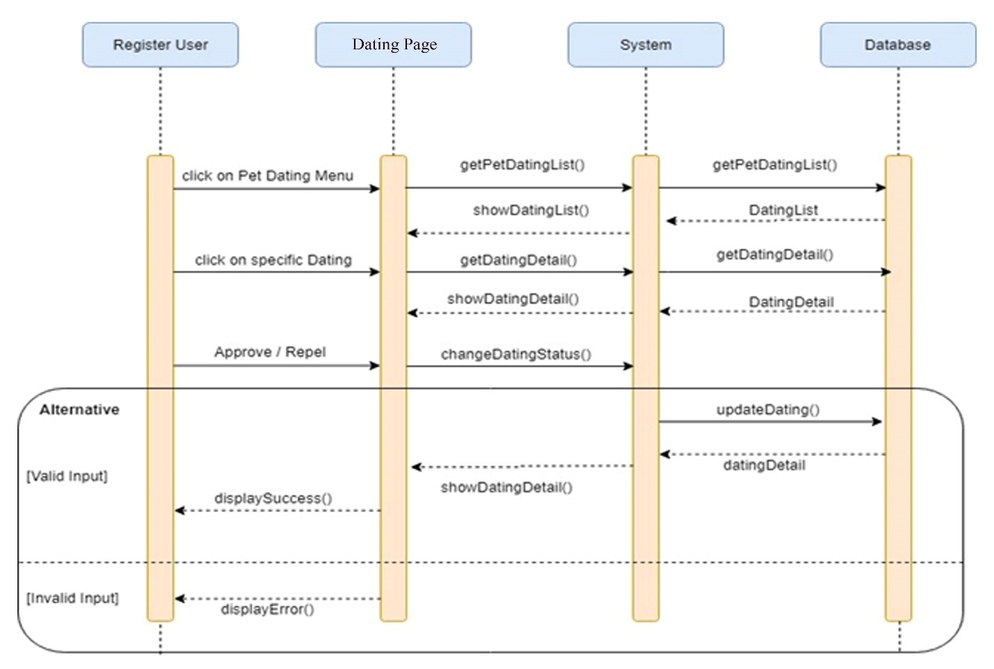

# Entity Relationship Diagram (ERD)

* + - 1. **Logical ERD**

## C:\Users\Elisa Muoi\Downloads\58113561_324461548261241_7268255155089309696_n.jpg

* + - 1. **Physical ERD**

**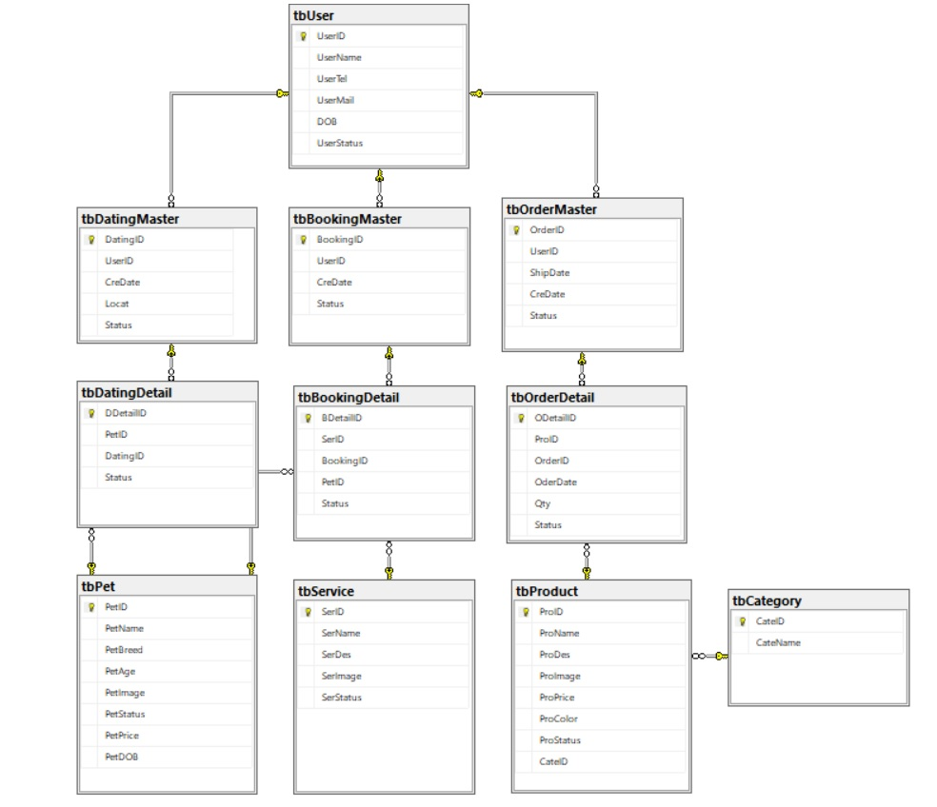**

# Entity Properties

1. **User**

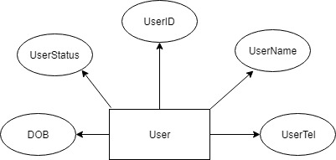

1. **Dating**
   1. Dating Master:

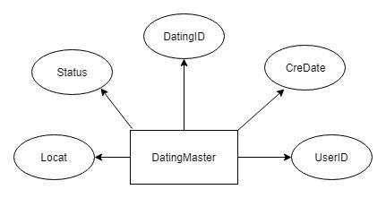

* 1. Dating Detail:

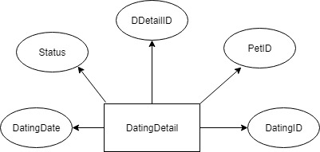

* 1. Pet:

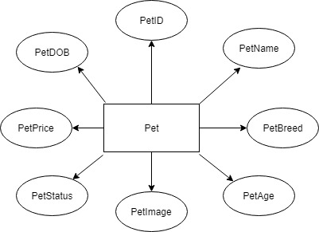

1. **Booking Service**
   1. Booking Master:

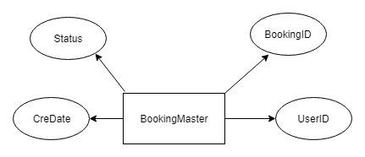

* 1. Booking Detail:

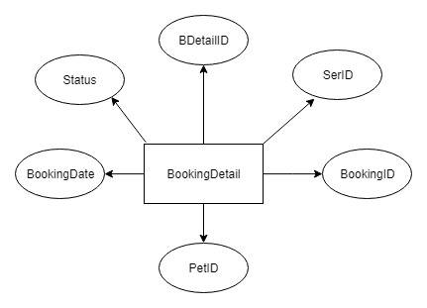

* 1. Service:

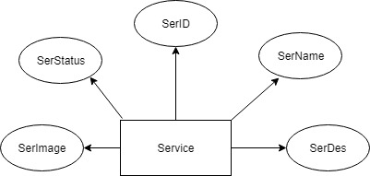

1. **Order Product**
   1. Order Master:

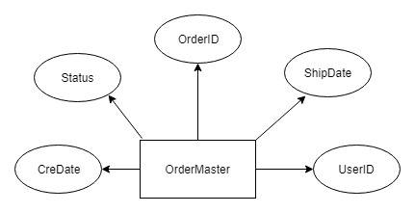

* 1. Order Detail:

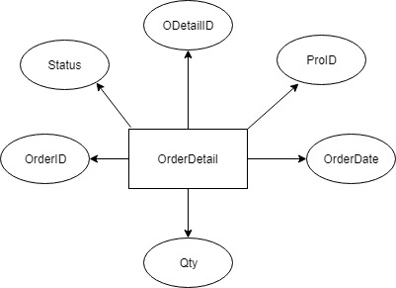

* 1. Category

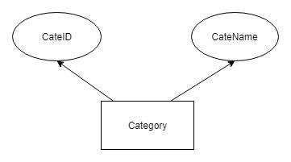

* 1. Product:

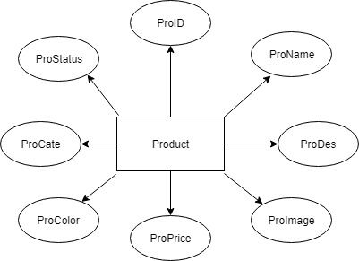

# Table Design

## **1.User**

|  |  |  |  |  |
| --- | --- | --- | --- | --- |
| **Table: tbUser** | | | | |
| **No.** | **Column Name** | **Data Type** | **Constraint** | **Description** |
| 1 | UserID | INT  IDENTITY(1,1) | NOT NULL PRIMARY KEY | ID of user |
| 2 | UserName | VARCHAR(50) | NOT NULL | name of user |
| 3 | UserTel | INT | NOT NULL  UNIQUE | phone of user |
| 4 | UserMail | VARCHAR(50) | NOT NULL | mail of user |
| 5 | DOB | DATETIME | NOT NULL | Date of birth |
| 6 | UserStatus | BIT | NOT NULL | User’s status |

**2.Pet**

|  |  |  |  |  |
| --- | --- | --- | --- | --- |
| **Table: tbPet** | | | | |
| **No.** | **Column Name** | **Data Type** | **Constraint** | **Description** |
| 1 | PetID | INT  IDENTITY(1,1) | NOT NULL PRIMARY KEY | ID of Pet |
| 2 | PetName | VARCHAR(50) | NOT NULL | name of Pet |
| 3 | PetBreed | VARCHAR(20) | NOT NULL | breed of Pet |
| 4 | PetImage | VARCHAR(50) | NOT NULL | Image of Pet |
| 5 | PetStatus | BIT | NOT NULL | Pet’s status |
| 6 | PetPrice | INT | NOT NULL | Price of Pet |
| 7 | PetDOB | DATETIME | NOT NULL | Date of birth of Pet |

**3.Dating Detail**

|  |  |  |  |  |
| --- | --- | --- | --- | --- |
| **Table: tbDatingDetail** | | | | |
| **No.** | **Column Name** | **Data Type** | **Constraint** | **Description** |
| 1 | DDetailID | INT  IDENTITY(1,1) | NOT NULL PRIMARY KEY | ID of dating detail |
| 2 | PetID | INT | NOT NULL  FOREIGN KEY | ID of Pet |
| 3 | DatingID | INT | NOT NULL  FOREIGN KEY | ID of Dating Master |
| 4 | DatingDate | DATETIME | NOT NULL | Dating date |
| 5 | Status | BIT | NOT NULL | Dating detail’s status |

# 4.Dating Master

|  |  |  |  |  |
| --- | --- | --- | --- | --- |
| **Table: tbDatingMaster** | | | | |
| **No.** | **Column Name** | **Data Type** | **Constraint** | **Description** |
| 1 | DatingID | INT  IDENTITY(1,1) | NOT NULL PRIMARY KEY | ID of Dating |
| 2 | UserID | INT | NOT NULL  FOREIGN KEY | ID of User |
| 3 | CreDate | DATETIME | NOT NULL | Creating date |
| 4 | Locat | VARCHAR(50) | NOT NULL | Location of dating |
| 5 | Status | BIT | NOT NULL | Status of dating |

**5.Service**

|  |  |  |  |  |
| --- | --- | --- | --- | --- |
| **Table: tbService** | | | | |
| **No.** | **Column Name** | **Data Type** | **Constraint** | **Description** |
| 1 | SerID | INT  IDENTITY(1,1) | NOT NULL PRIMARY KEY | ID of Service |
| 2 | SerName | VARCHAR(50) | NOT NULL | name of Service |
| 3 | SerDes | VARCHAR(50) | NOT NULL | description |
| 4 | SerImage | VARCHAR(50) | NOT NULL | Image of Service |
| 5 | SerStatus | BIT | NOT NULL | Service ‘s status |

**6.Booking Detail**

|  |  |  |  |  |
| --- | --- | --- | --- | --- |
| **Table: tbBookingDetail** | | | | |
| **No.** | **Column Name** | **Data Type** | **Constraint** | **Description** |
| 1 | BDetailID | INT  IDENTITY(1,1) | NOT NULL PRIMARY KEY | ID of Booking detail |
| 2 | SerID | INT | NOT NULL  FOREIGN KEY | ID of Service |
| 3 | BookingID | INT | NOT NULL  FOREIGN KEY | ID of Booking Master |
| 4 | BookingDate | DATETIME | NOT NULL | Booking date |
| 5 | Status | BIT | NOT NULL | Booking detail’s status |

**7.Booking Master**

|  |  |  |  |  |
| --- | --- | --- | --- | --- |
| **Table: tbBookingMaster** | | | | |
| **No.** | **Column Name** | **Data Type** | **Constraint** | **Description** |
| 1 | BookingID | INT  IDENTITY(1,1) | NOT NULL PRIMARY KEY | ID of Booking |
| 2 | UserID | INT | NOT NULL  FOREIGN KEY | ID of User |
| 3 | CreDate | DATETIME | NOT NULL | Creating date |
| 4 | Status | BIT | NOT NULL | Status of dating |

**8.Product**

|  |  |  |  |  |
| --- | --- | --- | --- | --- |
| **Table: tbProduct** | | | | |
| **No.** | **Column Name** | **Data Type** | **Constraint** | **Description** |
| 1 | ProID | INT  IDENTITY(1,1) | NOT NULL PRIMARY KEY | ID of Product |
| 2 | ProName | VARCHAR(50) | NOT NULL | name of Product |
| 3 | ProDes | VARCHAR(50) | NOT NULL | Description |
| 4 | ProImage | VARCHAR(50) | NOT NULL | Image of Product |
| 5 | ProStatus | BIT | NOT NULL | Produc’s status |
| 6 | ProPrice | INT | NOT NULL | Price of Product |
| 7 | CateID | INT | NOT NULL  FOREIGN KEY | Category’s ID |

**9. Category**

|  |  |  |  |  |
| --- | --- | --- | --- | --- |
| **Table: tbCategory** | | | | |
| **No.** | **Column Name** | **Data Type** | **Constraint** | **Description** |
| 1 | CateID | INT  IDENTITY(1,1) | NOT NULL PRIMARY KEY | ID of Category |
| 2 | CateName | VARCHAR(20) | NOT NULL | name of Category |

**10.Order Detail**

|  |  |  |  |  |
| --- | --- | --- | --- | --- |
| **Table: tbOrderDetail** | | | | |
| **No.** | **Column Name** | **Data Type** | **Constraint** | **Description** |
| 1 | ODetailID | INT  IDENTITY(1,1) | NOT NULL PRIMARY KEY | ID of Order detail |
| 2 | ProID | INT | NOT NULL  FOREIGN KEY | ID of Product |
| 3 | Qty | INT | NOT NULL | Quantity |
| 4 | OrderDate | DATETIME | NOT NULL | order date |
| 5 | Status | BIT | NOT NULL | Order detail’s status |
| 6 | OrderID | INT | NOT NULL FOREIGN KEY | ID of Order master |

**11. Order Master**

|  |  |  |  |  |
| --- | --- | --- | --- | --- |
| **Table: tbOrderMaster** | | | | |
| **No.** | **Column Name** | **Data Type** | **Constraint** | **Description** |
| 1 | OrderID | INT  IDENTITY(1,1) | NOT NULL PRIMARY KEY | ID of Order Master |
| 2 | UserID | INT | NOT NULL  FOREIGN KEY | ID of User |
| 3 | CreDate | DATETIME | NOT NULL | Creating date |
| 4 | ShipDate | DATETIME | NOT NULL | Shipping Date |
| 5 | Status | BIT | NOT NULL | Status of order master |

REVIEW 2 – TASK SHEET

|  |  |  |  |  |  |
| --- | --- | --- | --- | --- | --- |
| No. | Contents | Member | Activity Plan | Preparation | |
| Start Date | Actual Days | Status |
| 1 | Use Case and Sequence Diagram   1. Service 2. Product, Category 3. Pet, Pet Dating | All members:   1. Tran Tan Duy 2. Tran Thi Tuyet Duyen 3. Le Cong Dat | 10/04/2019 | 7 | Completed |
| 2 | Entity Relationship Diagram (ERD) | Le Cong Dat |
| 3 | Entity Properties | Tran Tan Duy |
| 4 | Table Design | Tran Thi Tuyet Duyen |

Plan prepared by: Group 2 April 20st, 2019  
 **Group Leader Faculty**

**Tran Thi Tuyet Duyen Mr. Cat Nghiem Hieu Tuan**

**REVIEW 3**

* + 1. **SITE MAP**

1. **Client’s site map**

***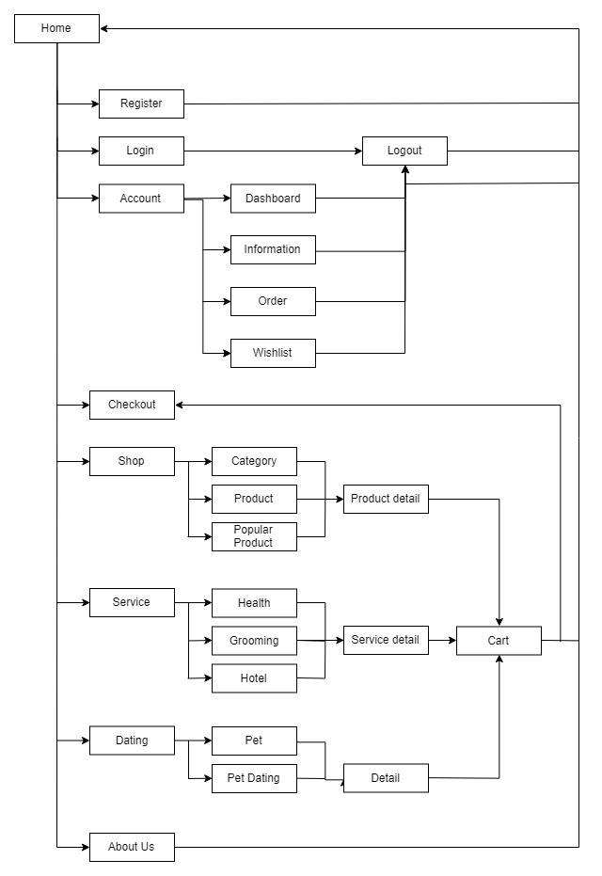***

**Admin’s site map**

**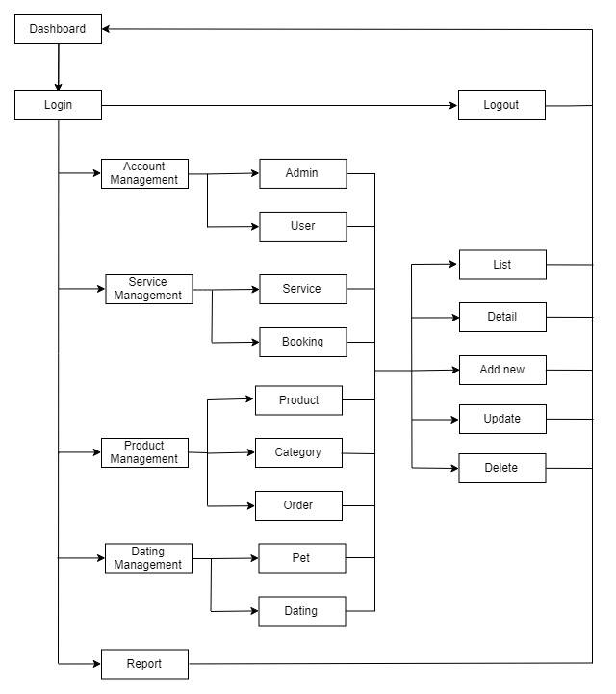**

* + 1. **GUI DESIGN**

1. **Client’s side**
   * 1. ***Home***

**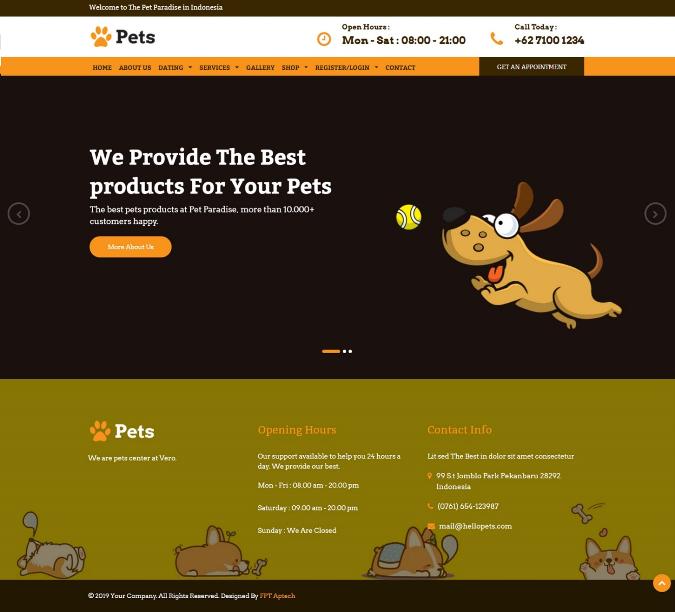**

|  |  |
| --- | --- |
| Description | Home page |
| Connect From | N/A |
| Connect To | Login page, Sign Up, Product page, Shop, Services, Gallery.. |
| Validation | N/A |
| Initial Values | N/A |
| Events | - Navigate the website by clicking on menu Shop, Service, .. |

* + 1. ***Register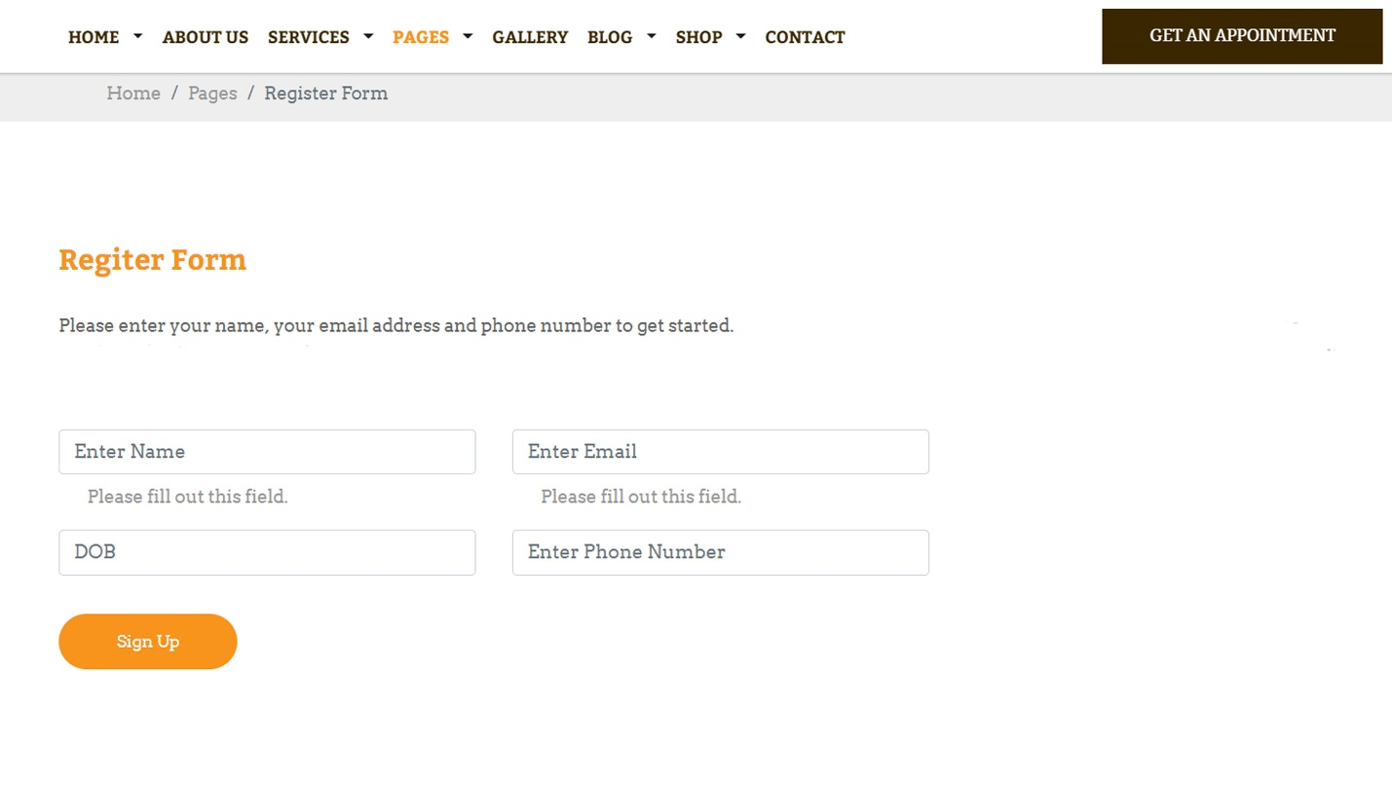***

|  |  |
| --- | --- |
| Description | Guest signs up for new account |
| Connect From | Home |
| Connect To | Login page, Home |
| Validation | - All fields: not blank  - Name: must be not contains special characters  - Email: must be valid email format  - Password: must be between 6 to 20 characters - Phone Number: must be unique, valid phone number |
| Initial Values | N/A |
| Events | - When click button "Sign Up", check phone and password. If success, go to login page |

* + 1. ***Login***

***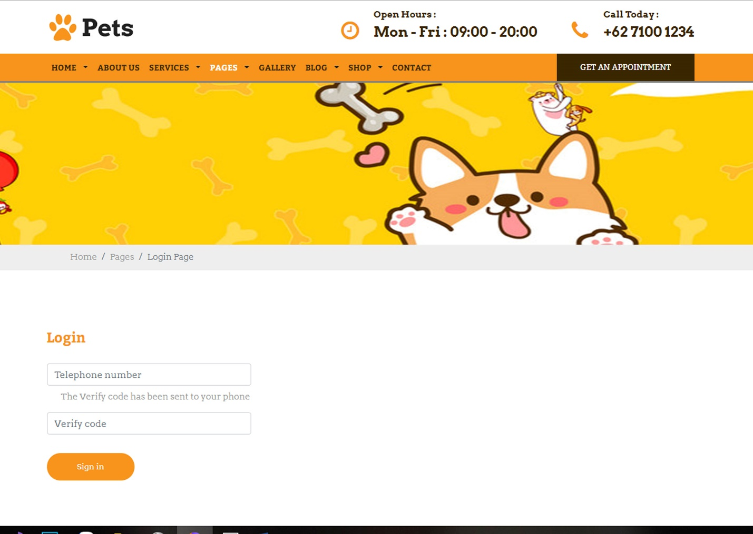***

|  |  |
| --- | --- |
| Description | Login with Phone Number and Verify code |
| Connect From | Home |
| Connect To | Customer’s profile |
| Validation | All fields: not blank - Phone: must be valid phone number format - Verify: from SMS |
| Initial Values | N/A |
| Events | - When click button "Sign In", check phone number, then login. Login success, go to profile page |

* + 1. ***Dating list***

***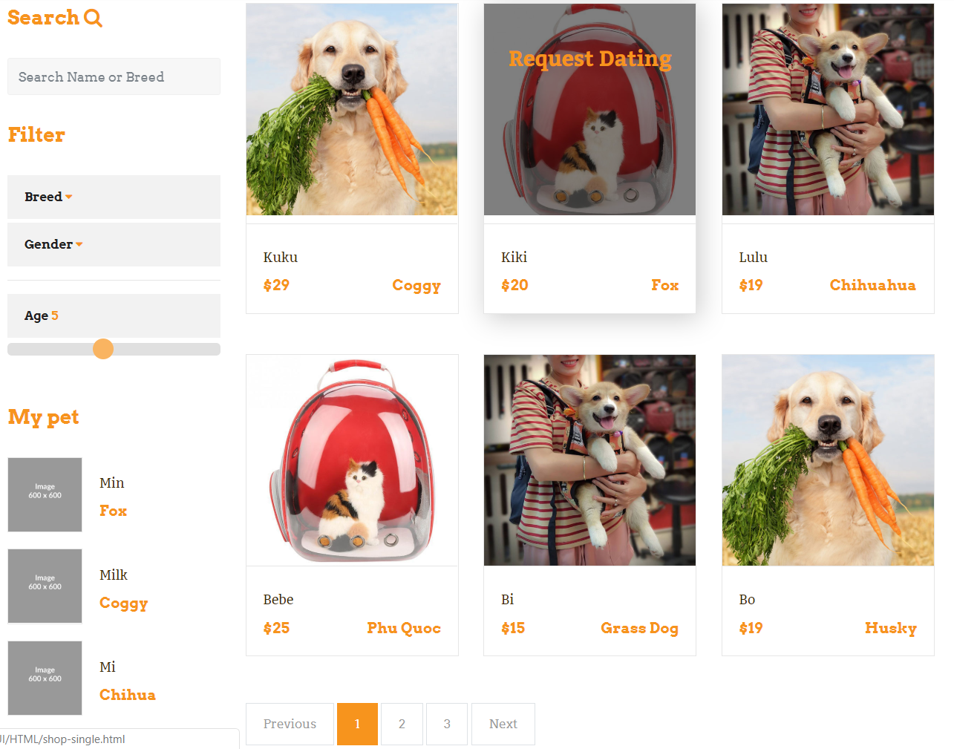***

|  |  |
| --- | --- |
| Description | Show list of Pet list, filter (breed, gender or age) and my pet, search (name, breed) |
| Connect From | Home |
| Connect To | Pet dating, Pet detail |
| Validation | N/A |
| Initial Values | List of pet dating |
| Events | - When click on pet dating, redirect to pet dating detail  - When click on my Pet, redirect to pet detail  - When click on gallery item, redirect to gallery detail |

* + 1. ***Pet Dating***

***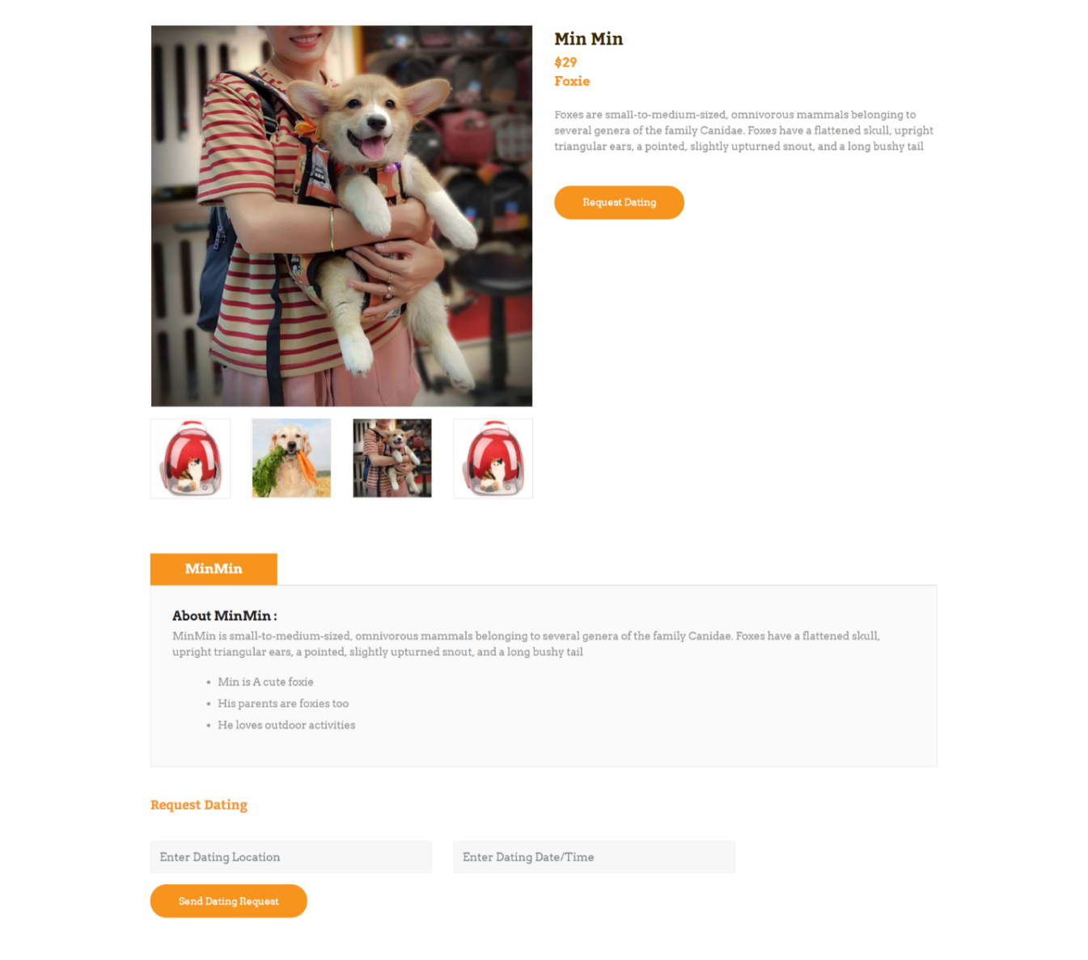***

|  |  |
| --- | --- |
| Description | Show the detail of pet which want to date |
| Connect From | Home |
| Connect To | Request dating |
| Validation | N/A |
| Initial Values | N/A |
| Events | - When click on ‘Send Dating Request, will send request to admin |

* + 1. ***Pet list***

***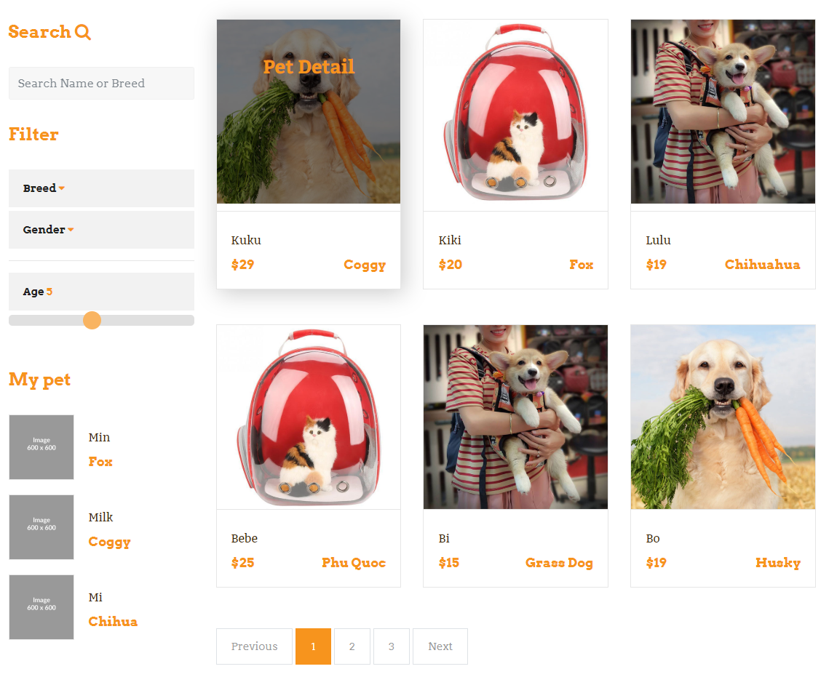***

|  |  |
| --- | --- |
| Description | Show list of Pet list, filter (breed, gender or age) and my pet, search (name, breed) |
| Connect From | Home |
| Connect To | Pet detail |
| Validation | N/A |
| Initial Values | Name, photo, price, … |
| Events | - When click on pet’s photo, redirect to pet detail |

* + 1. ***Pet detail***

***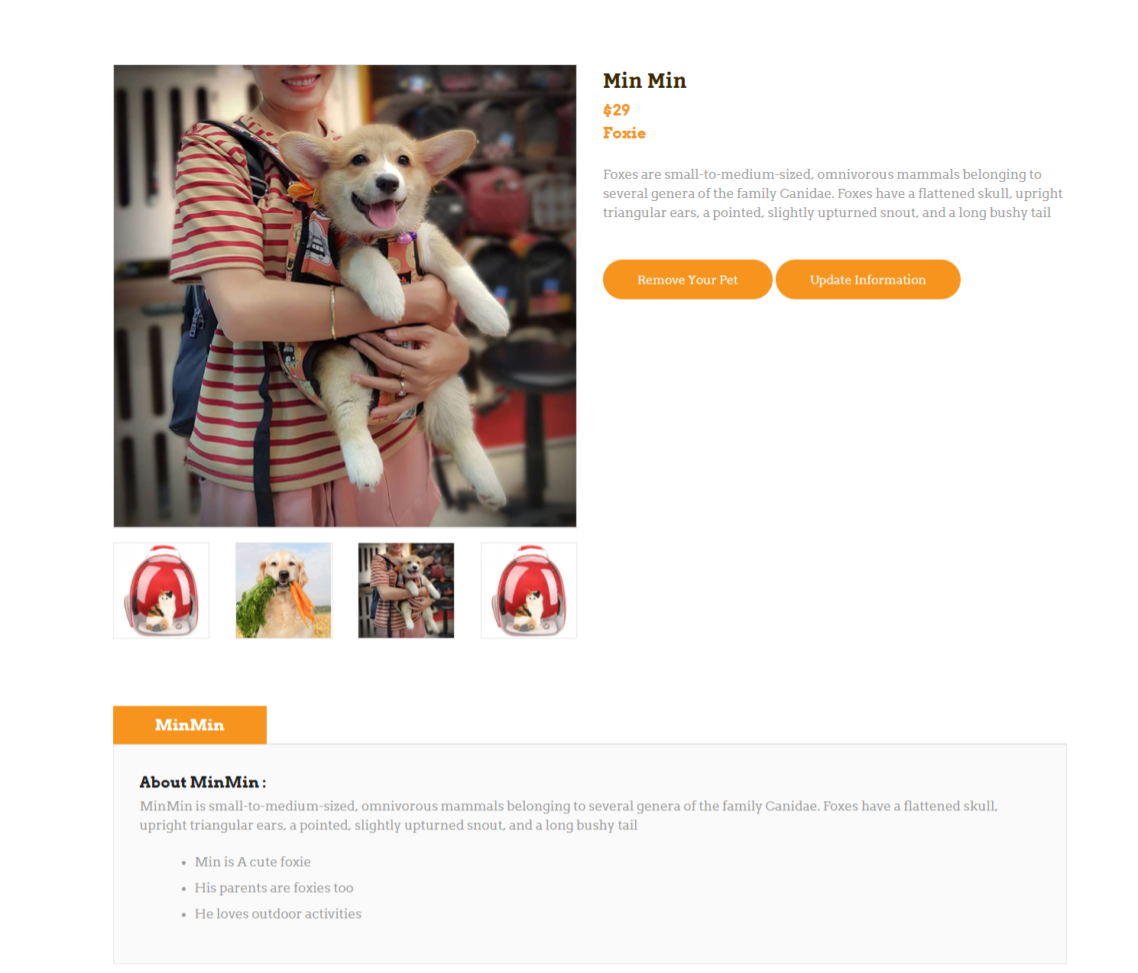***

|  |  |
| --- | --- |
| Description | Show Pet’s detail |
| Connect From | Home, Pet page |
| Connect To | Update information, remove your pet |
| Validation | N/A |
| Initial Values | Product’s detail: name, price, images, description |
| Events | - When click button “Buy now”🡪 product’s added to cart |

* + 1. ***Pet Add***

***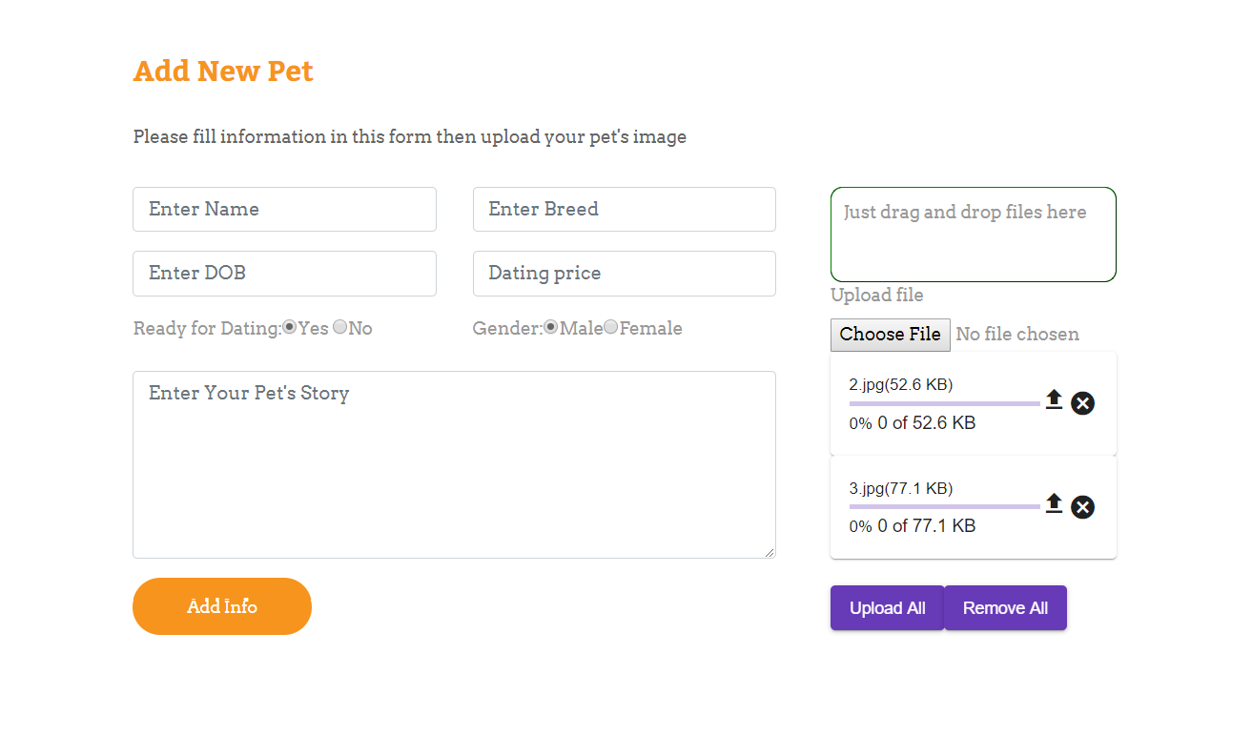***

|  |  |
| --- | --- |
| Description | Insert new pet |
| Connect From | Pet list |
| Connect To | Pet list page |
| Validation | - Not Blank: all fields - category name is unique  - name: varchar(50);  - breed: varchar(20);  - price >0, int |
| Initial Values | N/A |
| Events | - when click "Add info" button, save new Pet to database and go to pet-list page - when click "Remove All" button, reset all fields to blank |

* + 1. ***Pet Update***

***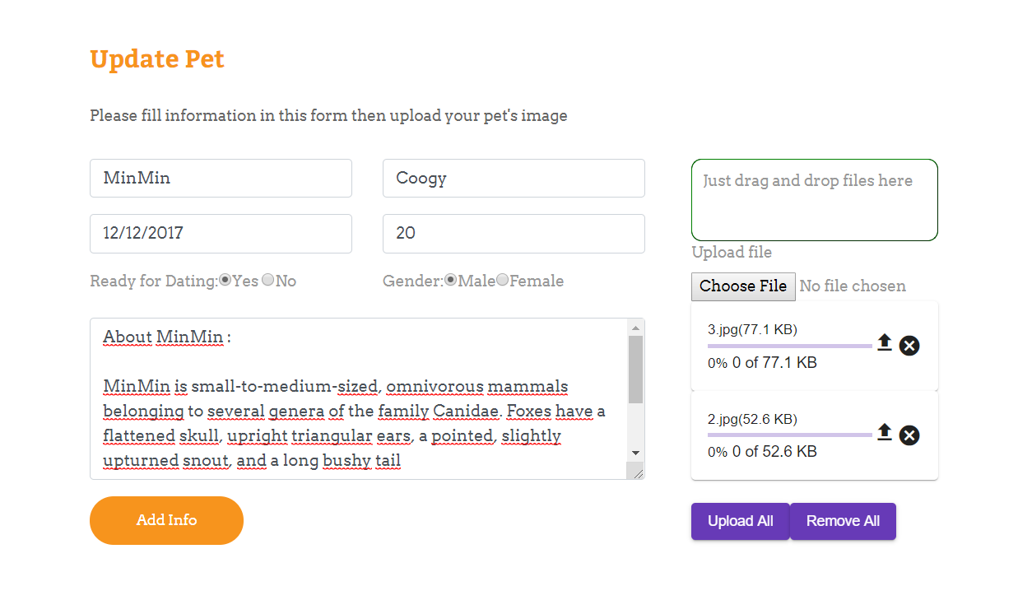***

|  |  |
| --- | --- |
| Description | Update Pet |
| Connect From | Pet detail page |
| Connect To | Pet-detail page |
| Validation | - Not Blank: all fields - category name is unique  - name: varchar(50);  - breed: varchar(20);  - price >0, int |
| Initial Values | pet parent list |
| Events | - when click "upload all" button, update pet to database and go to pet-dateil page - when click "Remove All" button, reset all fields to blank |

* + 1. ***Gallery***

***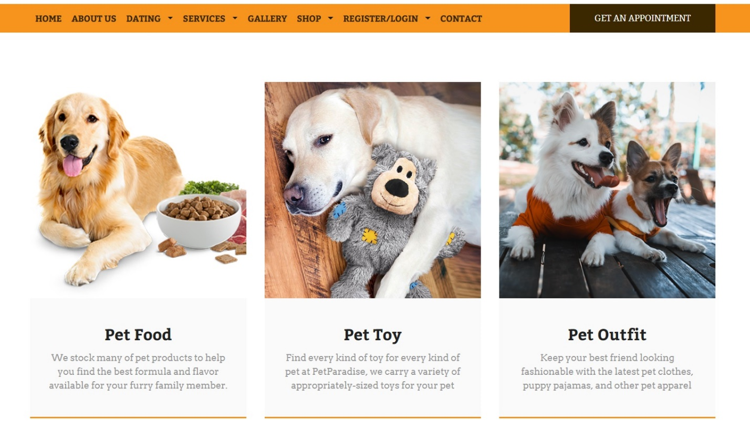***

|  |  |
| --- | --- |
| Description | All galleries will show up |
| Connect From | Home |
| Connect To | Shop |
| Validation | N/A |
| Initial Values | N/A |
| Events | - When click Gallery’s name or Gallery’s photo 🡪 products of that gallery will show up |

* + 1. ***Product***

***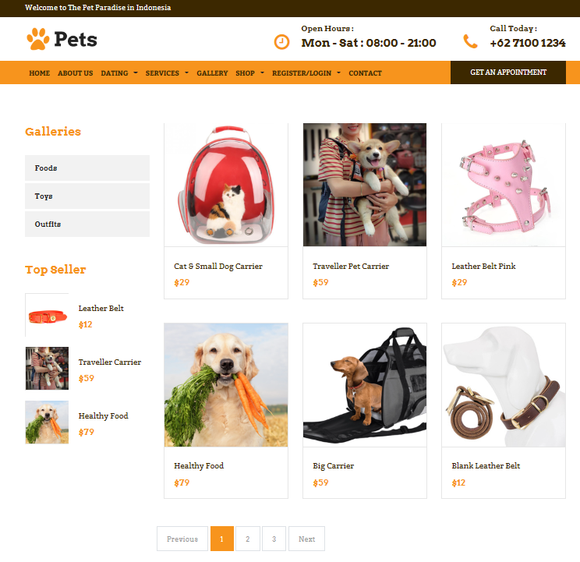***

|  |  |
| --- | --- |
| Description | Show list of products, galleries and top sellers |
| Connect From | Home, category |
| Connect To | Product detail, Top seller |
| Validation | N/A |
| Initial Values | List of products following given criteria (category, images, price, description) |
| Events | - When click on product, redirect to product detail  - When click on top seller product, redirect to product detail  - When click on gallery item, redirect to gallery detail |

* + 1. ***Product details***

***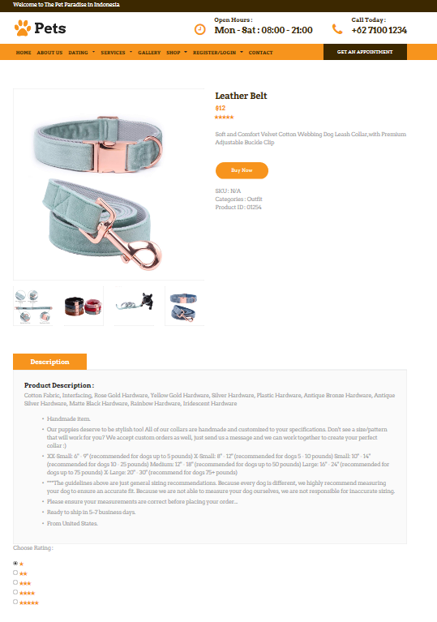­***

|  |  |
| --- | --- |
| Description | Show product’s detail |
| Connect From | Home, product page, cart |
| Connect To | Cart |
| Validation | N/A |
| Initial Values | Product’s detail: name, price, images, description |
| Events | - When click button “Buy now”🡪 product’s added to cart |

* + 1. ***Popular product (top seller)***

***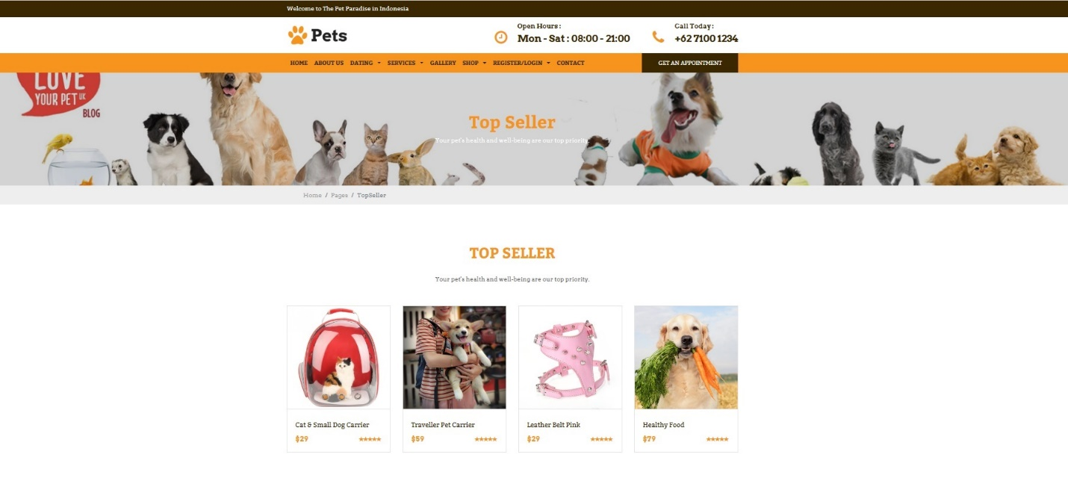***

|  |  |
| --- | --- |
| Description | Show popular products (top seller) |
| Connect From | Shop page |
| Connect To | Product’s detail |
| Validation | N/a |
| Initial Values | N/A |
| Events | - When click on product, redirect to product detail |

* + 1. ***About us***

***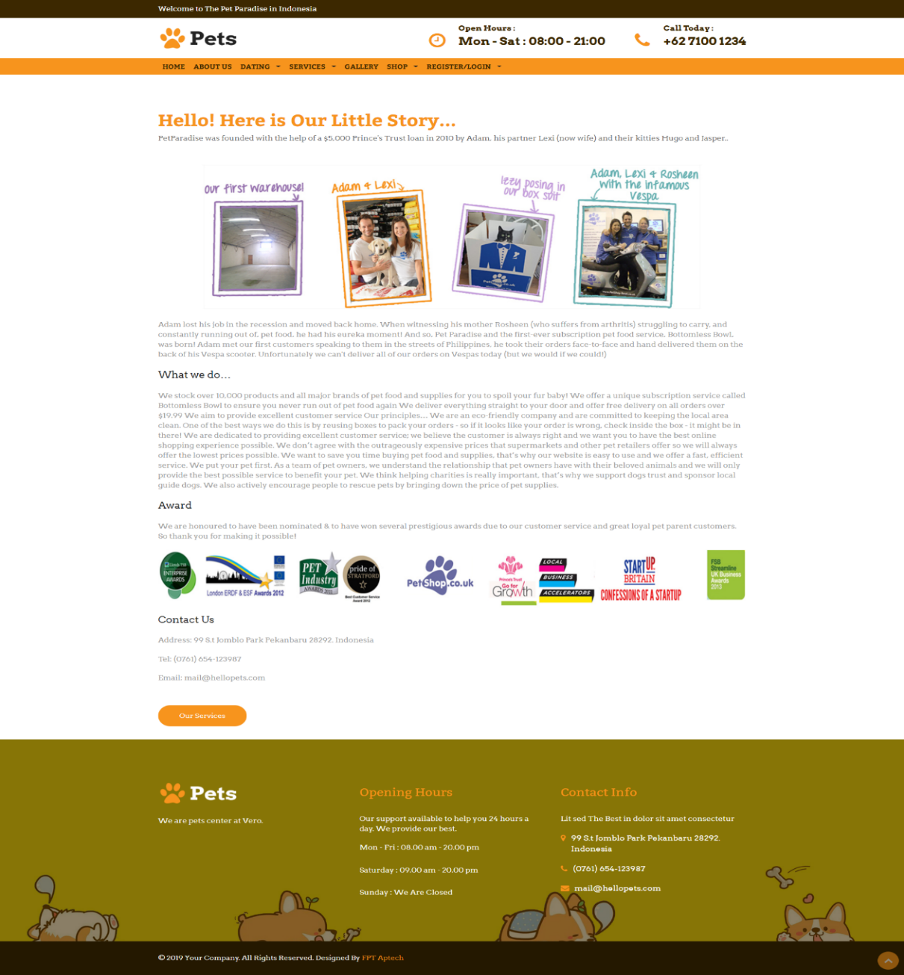***

|  |  |
| --- | --- |
| Description | About-Us page |
| Connect From | N/A |
| Connect To | N/A |
| Validation | N/A |
| Initial Values | N/A |
| Events | N/A |

* + 1. ***Cart page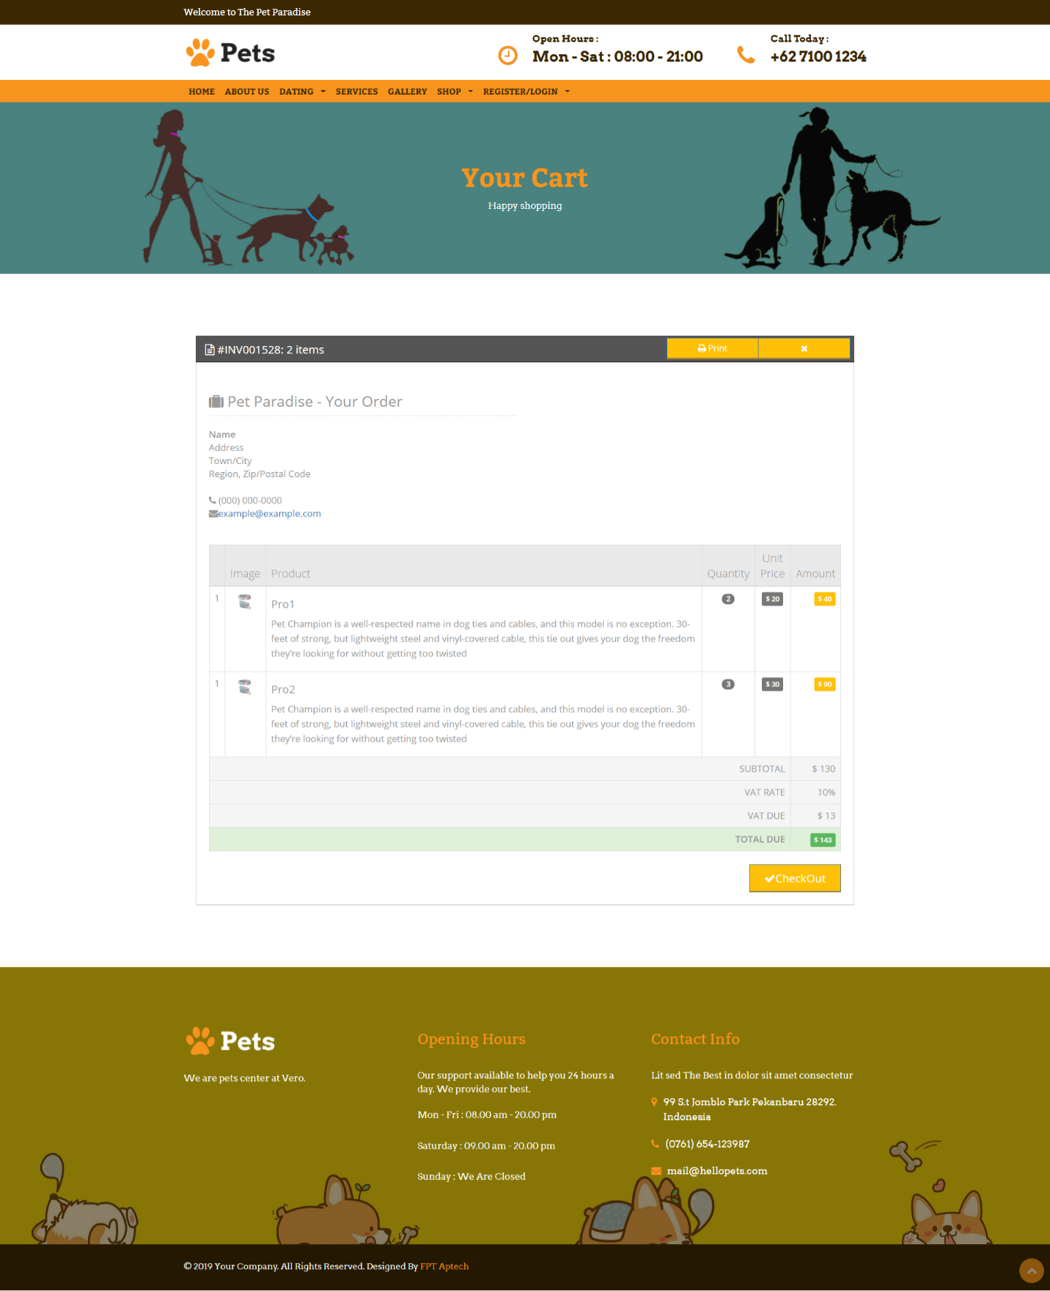***

|  |  |
| --- | --- |
| Description | Cart page |
| Connect From | Top Navigation |
| Connect To | Place Order page |
| Validation | Cart is not empty |
| Initial Values | List of products in cart |
| Events | - If customer is logged in, they can buy products  - When click “Checkout” button, redirect to payment page |

* + 1. ***Appointment form***

***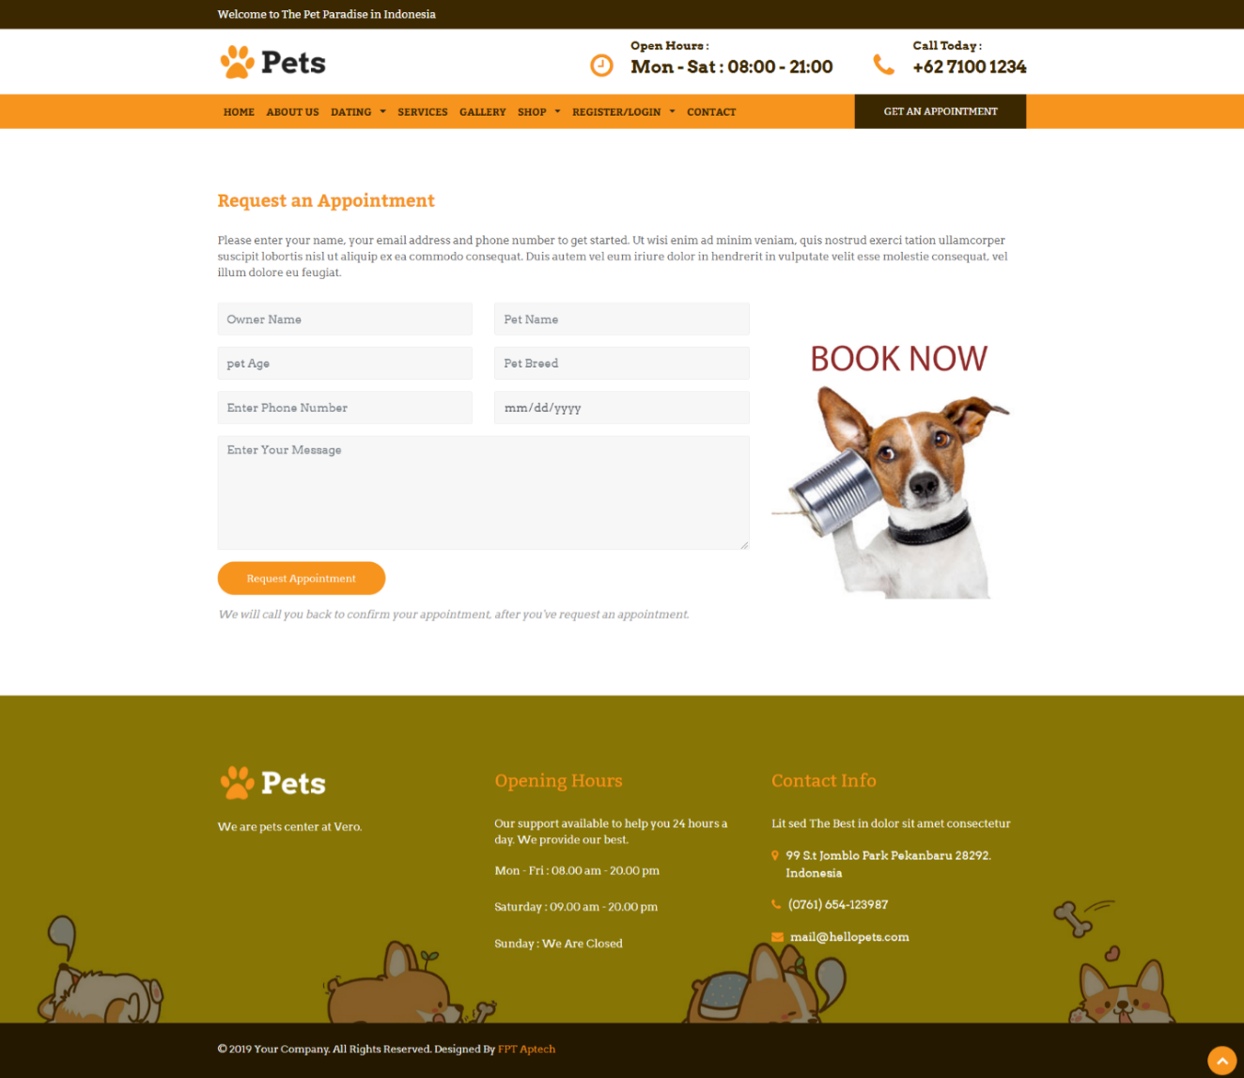***

|  |  |
| --- | --- |
| Description | Appointment form page |
| Connect From | Service detail, menu |
| Connect To | N/a |
| Validation | All fields is not empty |
| Initial Values | N/a |
| Events | - If customer is logged in, they can book appointment  - When click “Request appointment” button, will send the request to admin |

* + 1. ***Service***

**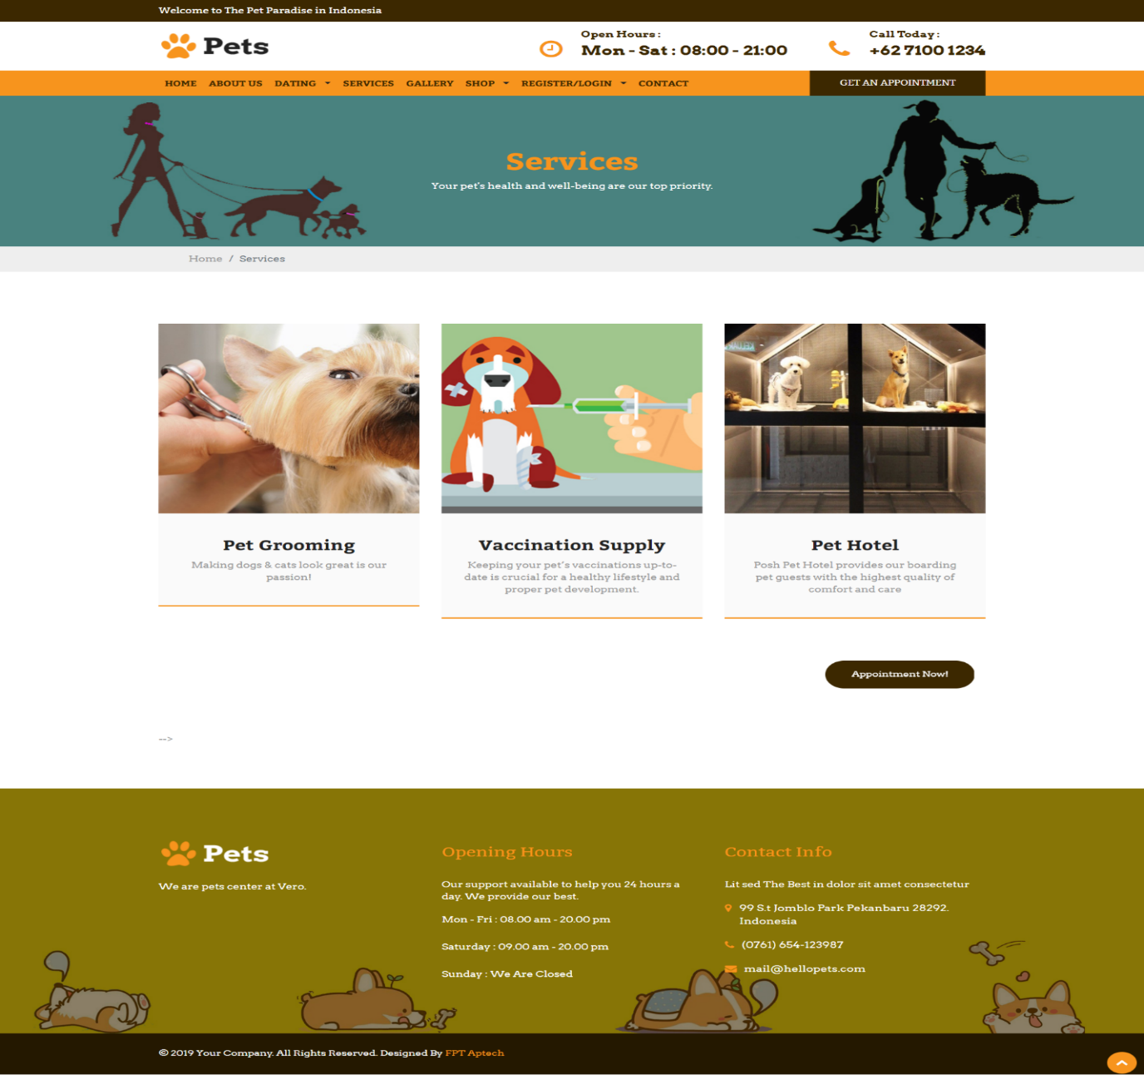**

|  |  |
| --- | --- |
| Description | Show list of service |
| Connect From | Home Service menu |
| Connect To | Service detail |
| Validation | N/A |
| Initial Values | List of Service following |
| Events | - When click on Service, redirect to Service details |

* + 1. ***Service Detail***

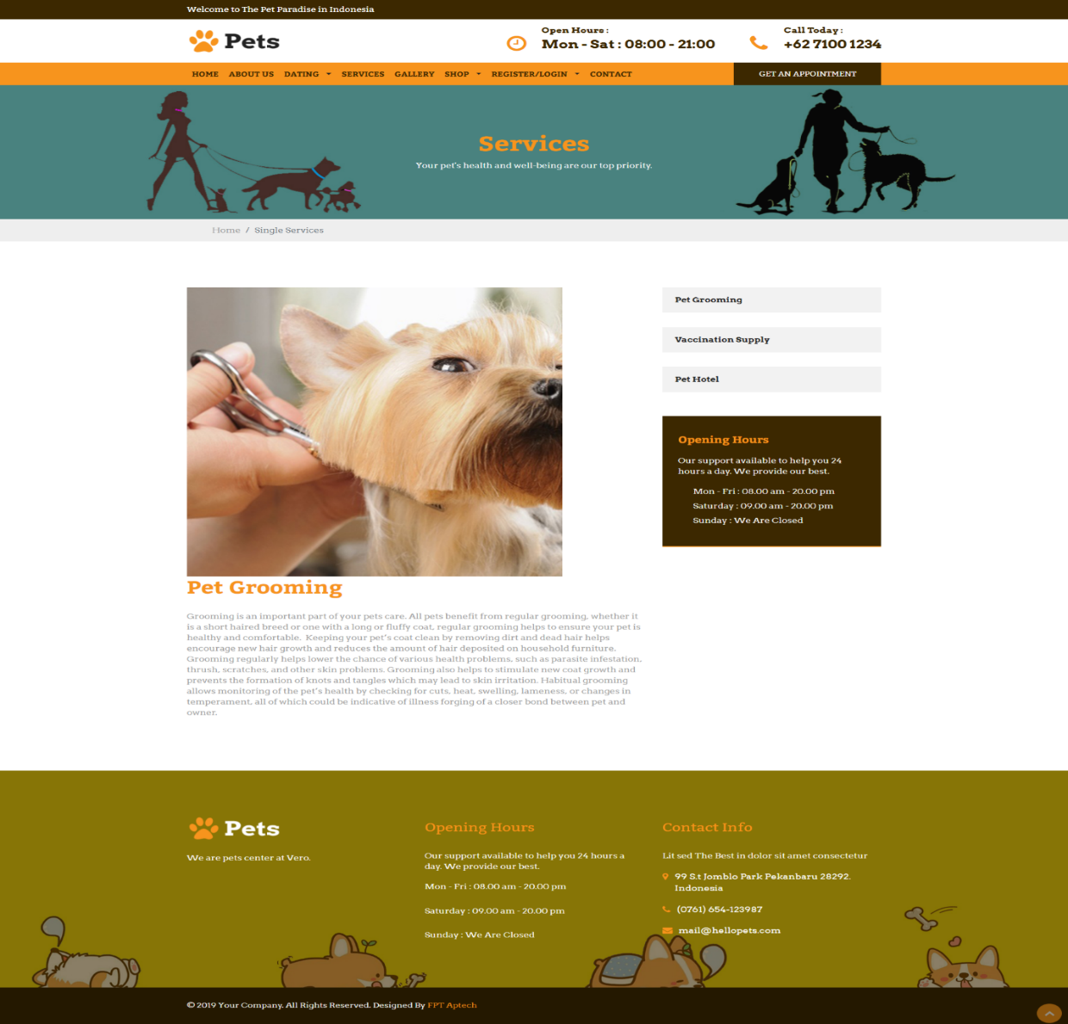

|  |  |
| --- | --- |
| Description | Show service’s detail |
| Connect From | Home, service’s page, |
| Connect To | Get Appointment page |
| Validation | N/A |
| Initial Values | information of Service following |
| Events | - When click button “Get Appointment”🡪 redirect to “Appointment form” page |

1. **Admin’s Site**
   * 1. ***Admin Login***

***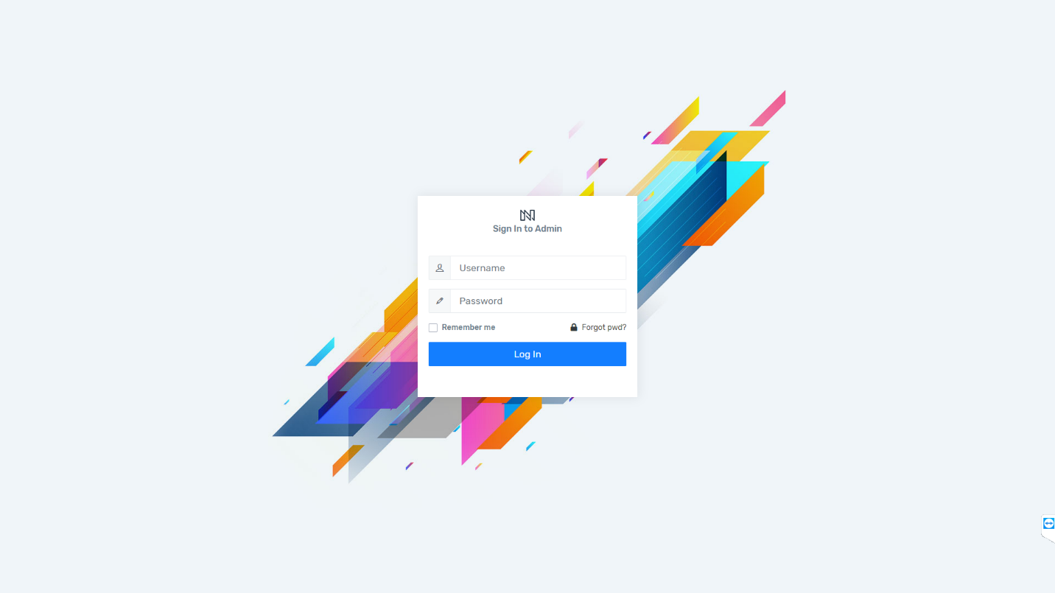***

|  |  |
| --- | --- |
| Description | Login as admin or super admin |
| Connect From | N/A |
| Connect To | Admin’s dashboard |
| Validation | - All fields: not blank - username must be more than 5 character - Password must be more than 6 character |
| Initial Values | N/A |
| Events | - When click button "Sign in", check username and password, then login - When click checkbox "Remember me", save username and password on browser's cookie  - When click checkbox "forget password", will send sms to your phone number |

* + 1. ***Admin’s Dashboard***

***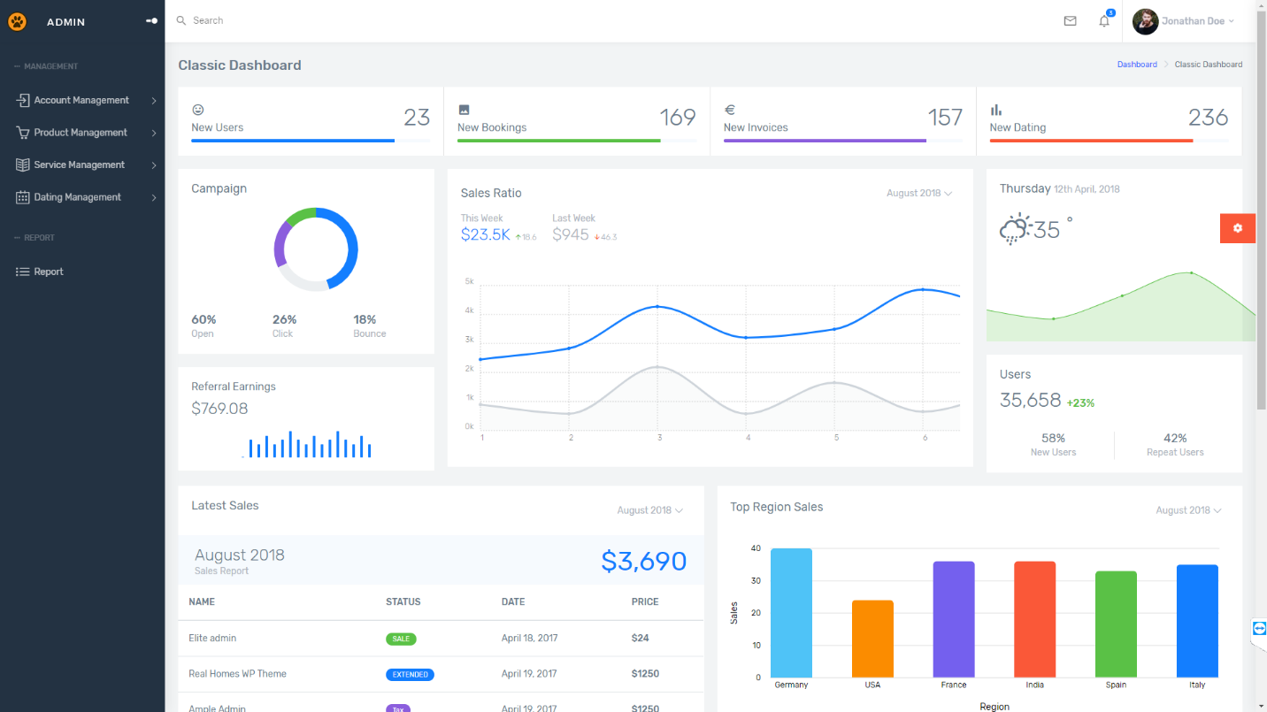***

|  |  |
| --- | --- |
| Description | Admin Dashboard |
| Connect From | Login page |
| Connect To | All |
| Validation | N/A |
| Initial Values | N/A |
| Events | - When click on menu tabs, redirect to respective pages |

* + 1. ***Customer list***

***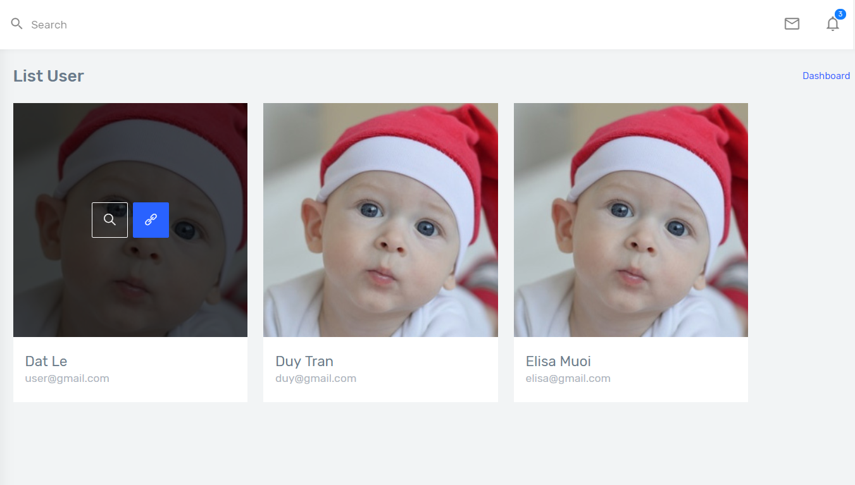***

|  |  |
| --- | --- |
| Description | Customer’s list (profile) |
| Connect From | Home, Login page |
| Connect To | Customer’s dashboard |
| Validation | Must log in to view |
| Initial Values | N/A |
| Events | - When click tab “photo”, view customer’s profile |

* + 1. ***Customer’s dashboard***

***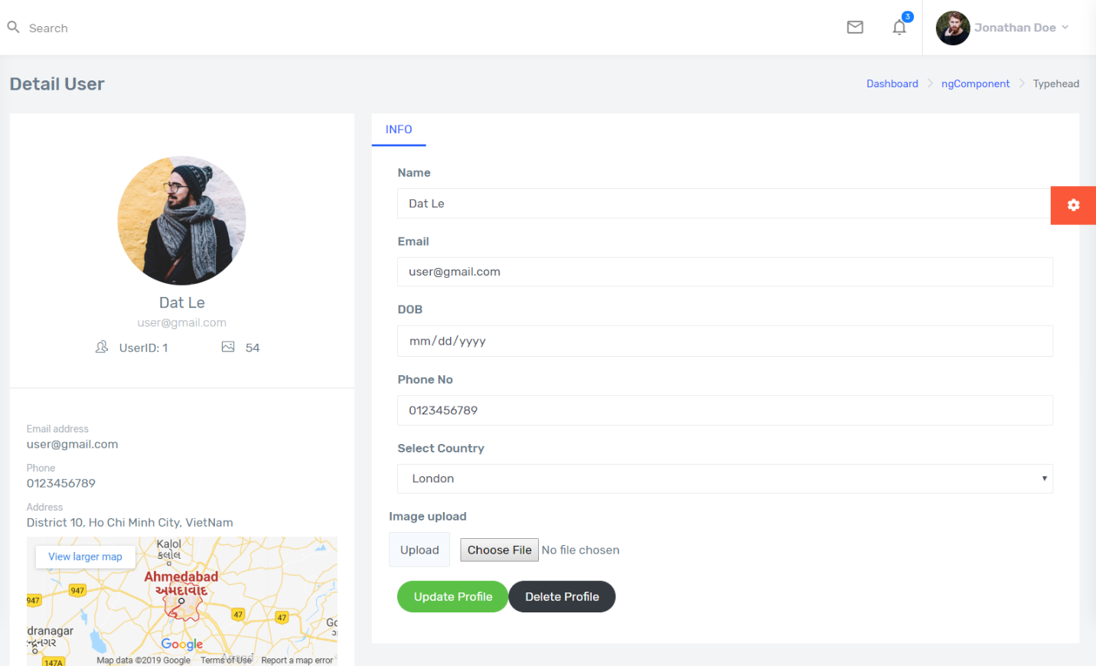***

|  |  |
| --- | --- |
| Description | Customer’s dashboard (profile) |
| Connect From | Home, Login page |
| Connect To | Update profile, delete profile |
| Validation | - All fields cannot be blank  - Name is no more than 50 characters  - Email: email type  - phone: number |
| Initial Values | Name, email, DOB, Telephone, country, image.. |
| Events | - When click tab “Update Profile”, view customer’s profile  - When click tab “delete profile”, view profile list |

* + 1. ***Category list***

***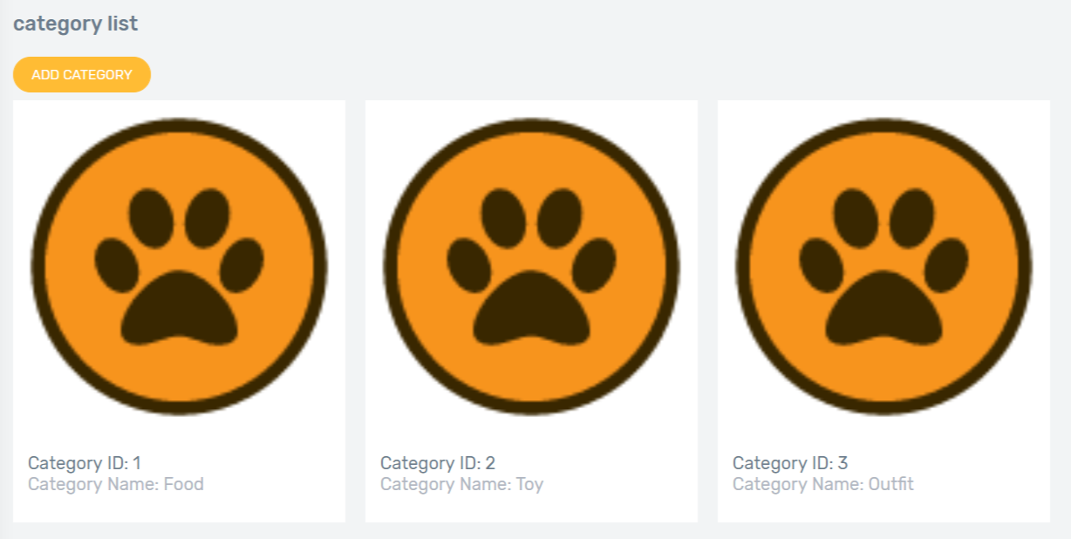***

|  |  |
| --- | --- |
| Description | Category overview |
| Connect From | Dashboard |
| Connect To | Category: update, delete |
| Validation | N/A |
| Initial Values | Category list |
| Events | - when select "link icon" option, show gallery detail  - when select "add category" option, show “add new category” page |

* + 1. ***Category add***

***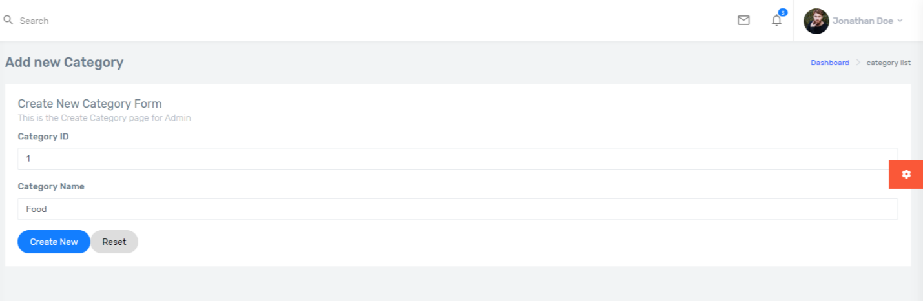***

|  |  |
| --- | --- |
| Description | Insert new category |
| Connect From | Category-overview page |
| Connect To | category-overview page |
| Validation | - Not Blank: category name - category name is unique |
| Initial Values | Category parent list |
| Events | - when click "Create" button, save new category to database and go to category-overview page - when click "Reset" button, reset all fields to blank |

* + 1. ***Category detail***

***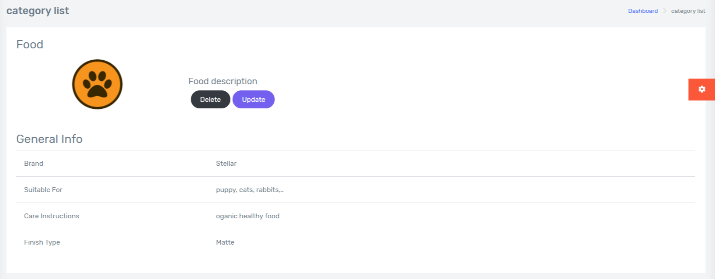***

|  |  |
| --- | --- |
| Description | Detail’s category |
| Connect From | Category-list page |
| Connect To | category-update page, category-delete page |
| Validation | N/a |
| Initial Values | Category detail following |
| Events | - when click "delete" button, redirect to “delete category” page - when click "update" button, redirect to “update category” page |

* + 1. ***Category update***

***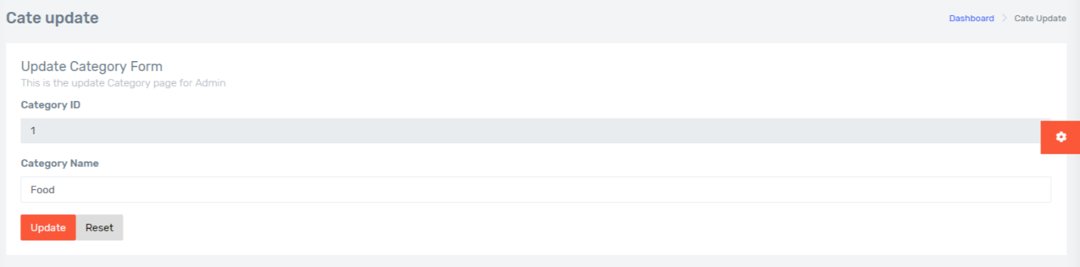***

|  |  |
| --- | --- |
| Description | Update category |
| Connect From | Category-overview page |
| Connect To | category-overview page |
| Validation | - Not Blank: category name - category name is unique |
| Initial Values | Category parent list |
| Events | - when click "Update" button, update category to database and go to category-overview page - when click "Reset" button, reset all fields to blank |

* + 1. ***Category delete***

******

|  |  |
| --- | --- |
| Description | delete category |
| Connect From | Category-overview page |
| Connect To | category-overview page |
| Validation | N/A |
| Initial Values | Category parent list |
| Events | - when click "delete" button, update category to database and go to category-overview page |

* + 1. ***Product list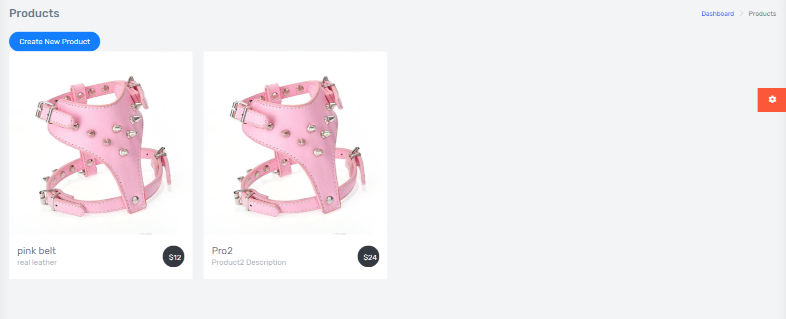***

|  |  |
| --- | --- |
| Description | Product list |
| Connect From | Dashboard |
| Connect To | Product detail |
| Validation | N/A |
| Initial Values | Product List |
| Events | - When click “link” icon, redirect to Product Detail  - When click “Create new product”, redirect to “Add new product” update |

* + 1. ***Product details***

***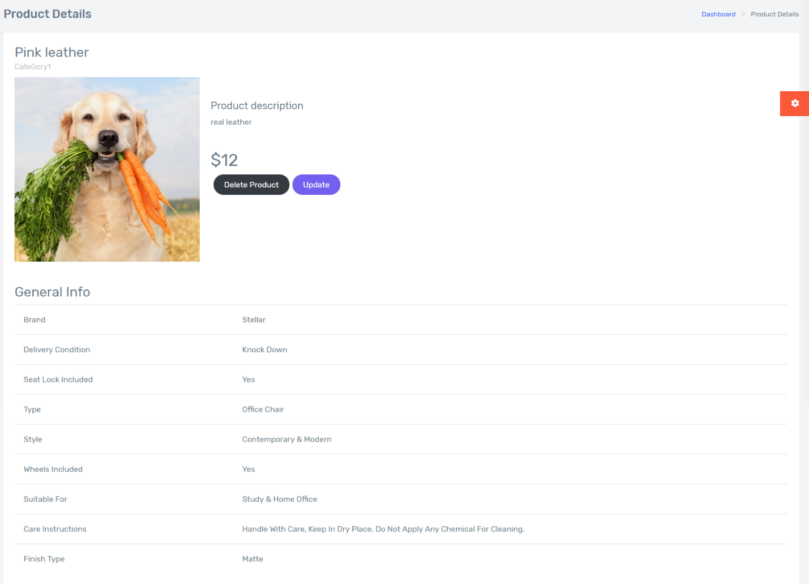***

|  |  |
| --- | --- |
| Description | Product Detail |
| Connect From | Product Page |
| Connect To | Product Update, Product Delete |
| Validation | N/A |
| Initial Values | Product Details |
| Events | - when click “Update Detail”, redirect to Update form  - when click “Delete Detail”, delete product |

* + 1. ***Product add***

***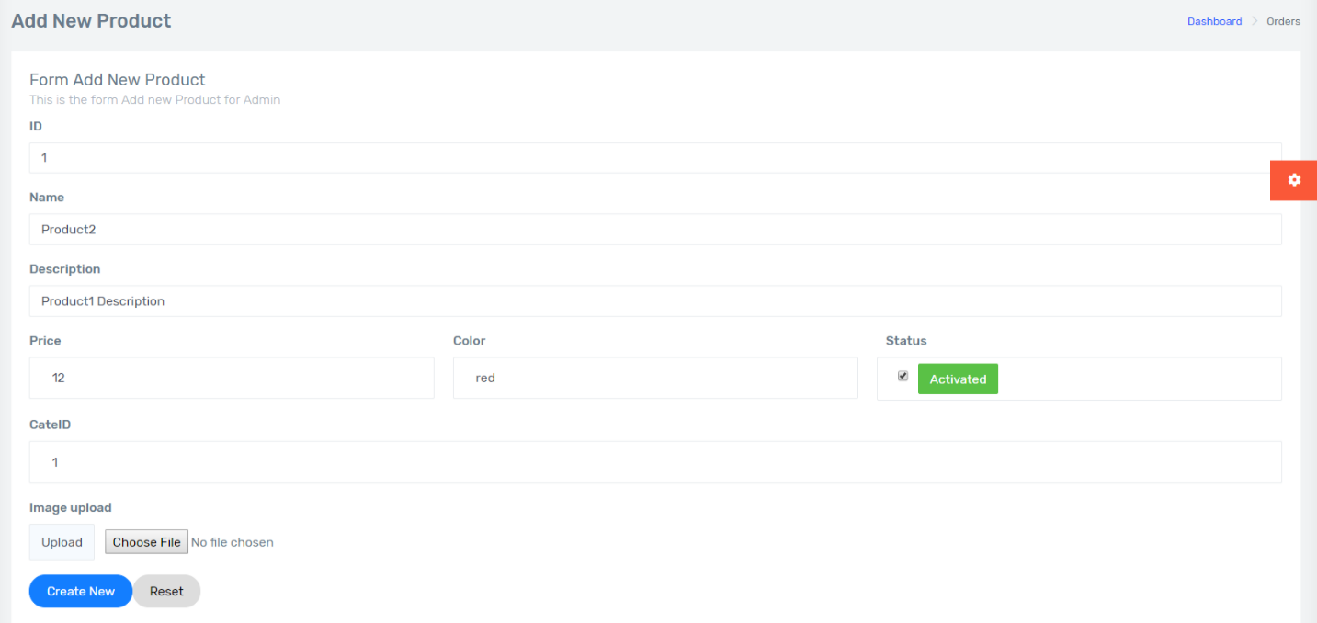***

|  |  |
| --- | --- |
| Description | Add new Product |
| Connect From | Product Detail, Product Page |
| Connect To | Product Detail |
| Validation | - All fields: not blank  - Category: not null |
| Initial Values | N/A |
| Events | - When click “Create New”, add product in database  - When click “Reset”, reset all fields |

* + 1. ***Product update***

***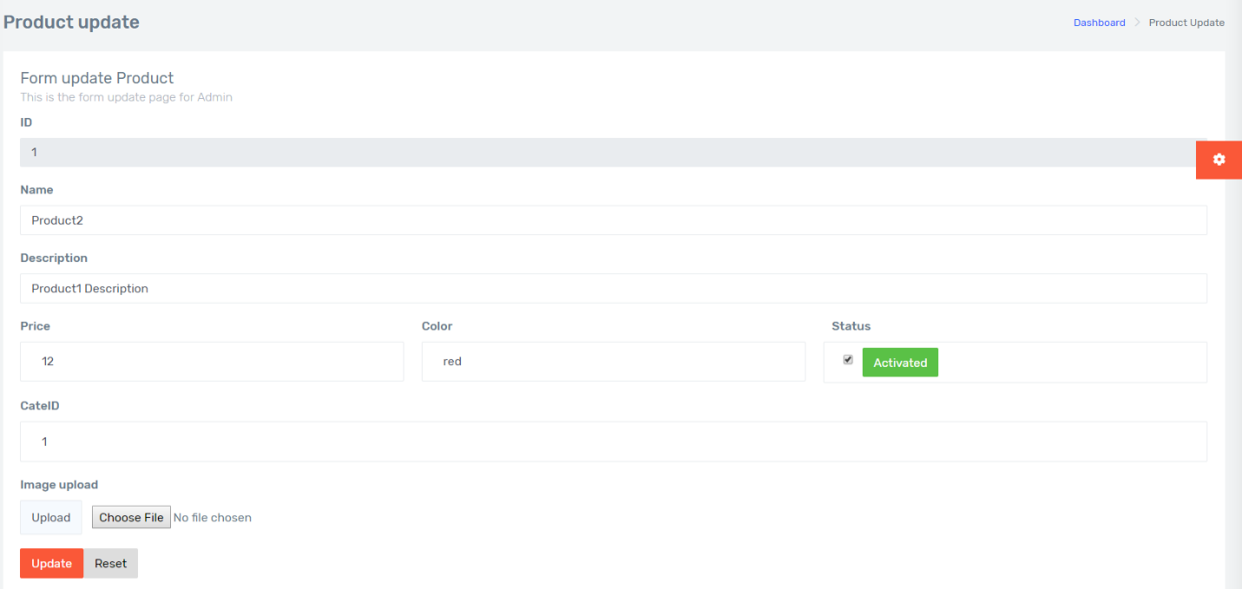***

|  |  |
| --- | --- |
| Description | Product Update |
| Connect From | Product Detail, Product Page |
| Connect To | Product Detail |
| Validation | - All fields: not blank  - Category: not null |
| Initial Values | - Product Detail |
| Events | - When click “Update”, update product in database  - When click “Reset”, reset all fields |

* + 1. ***Product delete***

******

|  |  |
| --- | --- |
| Description | Product Delete |
| Connect From | Product Page |
| Connect To | Product Update, Product Delete |
| Validation | N/A |
| Initial Values | Product Details |
| Events | - when click “Delete Detail”, delete product |

* + 1. ***Service List***

***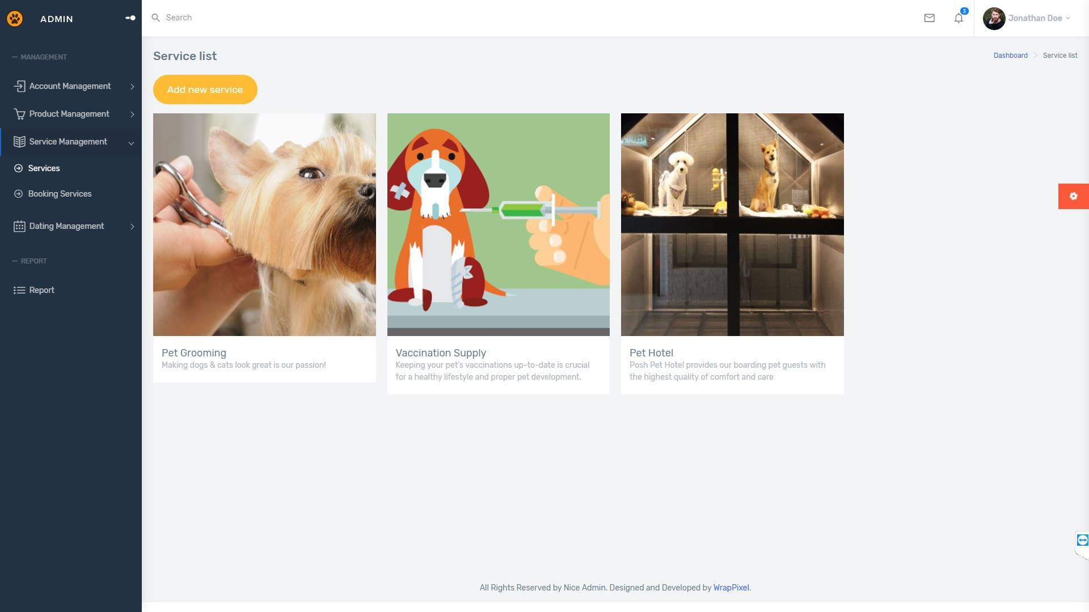***

|  |  |
| --- | --- |
| Description | List all services |
| Connect From | Sidebar’s Service Manage tab |
| Connect To | Service Detail  Create new Service  Service Edit |
| Validation | N/A |
| Initial Values | Service List |
| Events | - Click on button "Add new service": Go to Add new service page.  -Click on icon “Detail”: Go to Service detail page  -Click on icon “Edit”: Go to Service edit page |

* + 1. ***Service Add***

***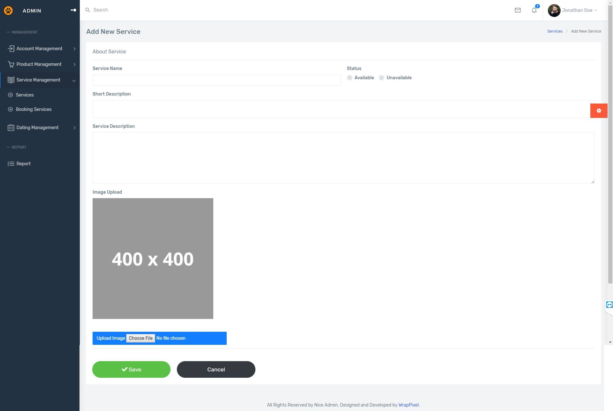***

|  |  |
| --- | --- |
| Description | Add a new service |
| Connect From | Service List page |
| Connect To | N/A |
| Validation | -All fields: not blank - Name: must be unique |
| Initial Values | N/A |
| Events | - Click on button "Save": check all field validation. Add a new service to database.  -Click on button “Cancel”: reset all field. |

* + 1. ***Service Update***

***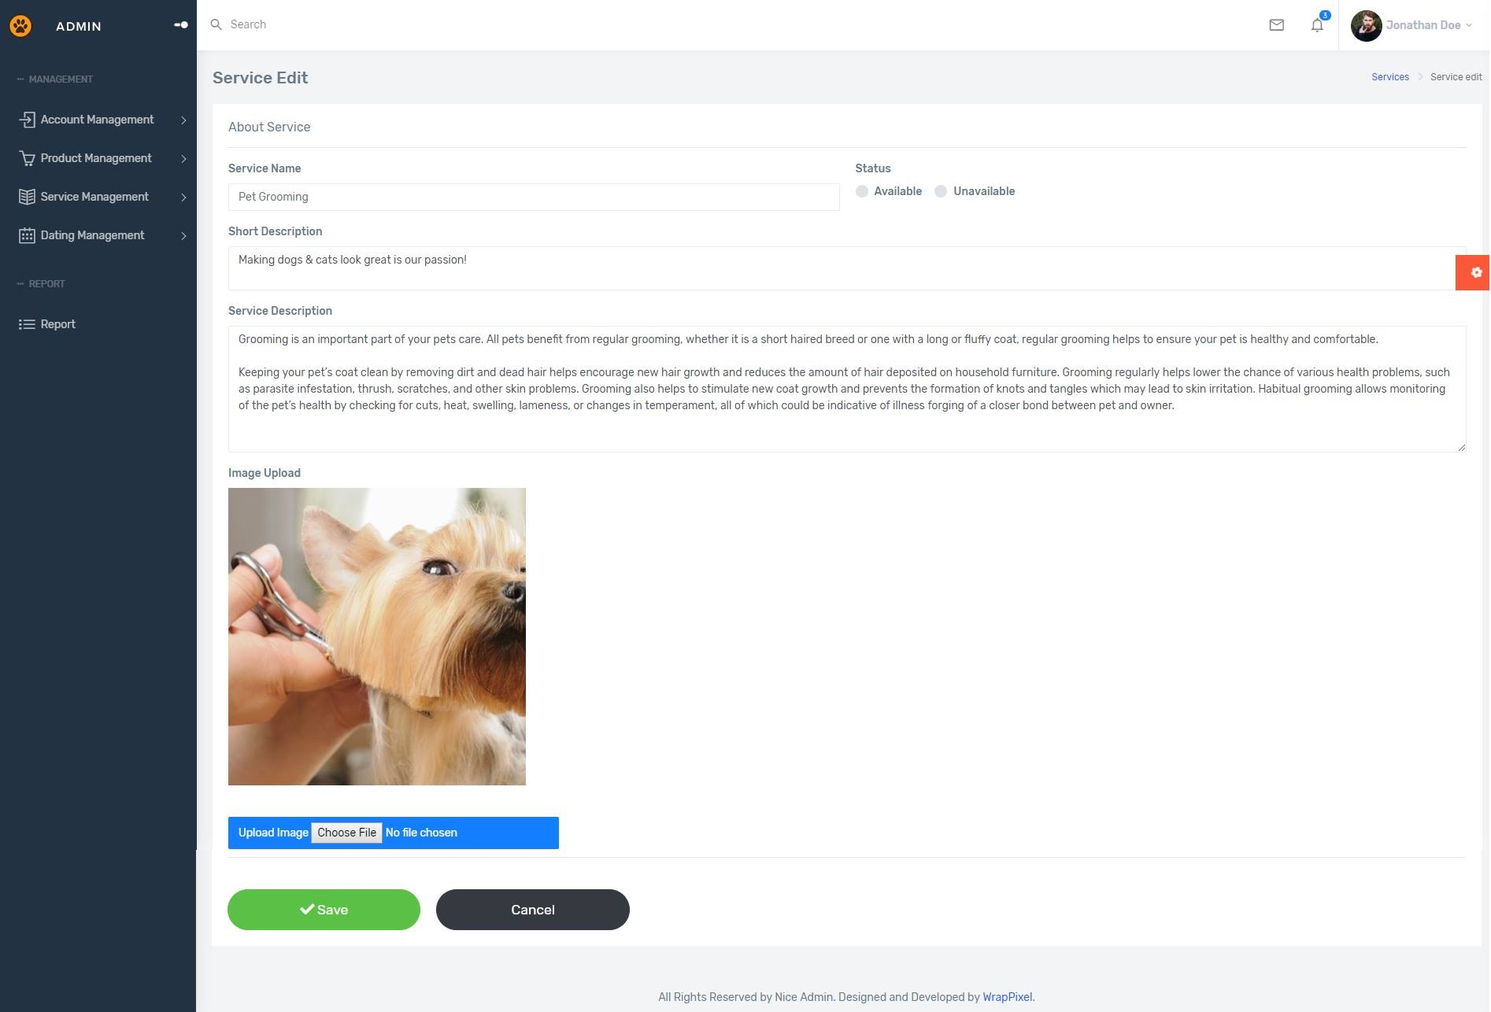***

|  |  |
| --- | --- |
| Description | Update Service |
| Connect From | Service List; Service Detail |
| Connect To | N/A |
| Validation | All fields: not blank - Name: must be unique |
| Initial Values | Product Detail |
| Events | - Click on button "Save": check all field validation. Update detail to database.  -Click on button “Cancel”: redirect to Service detail page. |

* + 1. ***Service Delete***

***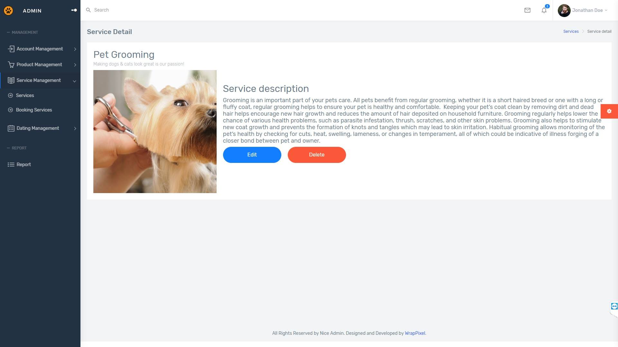***

|  |  |
| --- | --- |
| Description | Delete Service |
| Connect From | Service Detail |
| Connect To | N/A |
| Validation | N/A |
| Initial Values | Product Detail |
| Events | - Click on button "Delete": confirm again. Delete service from database. |

* + 1. ***List Pet***

***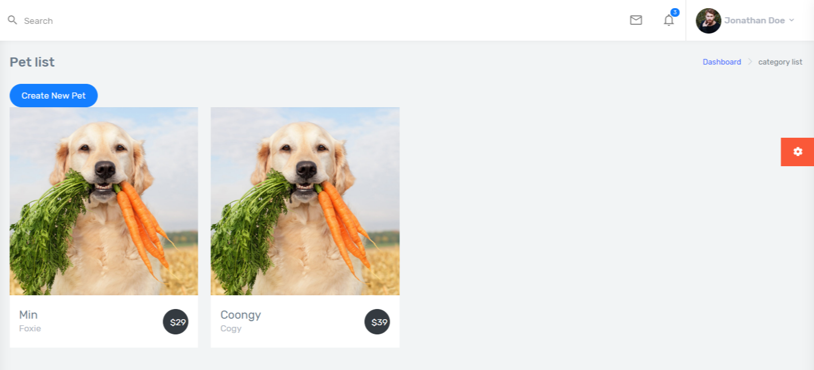***

|  |  |
| --- | --- |
| Description | Pet list |
| Connect From | Dashboard |
| Connect To | Pet detail |
| Validation | N/A |
| Initial Values | Product List |
| Events | - When click “link icon”, redirect to Pet Detail |

* + 1. ***Pet detail***

***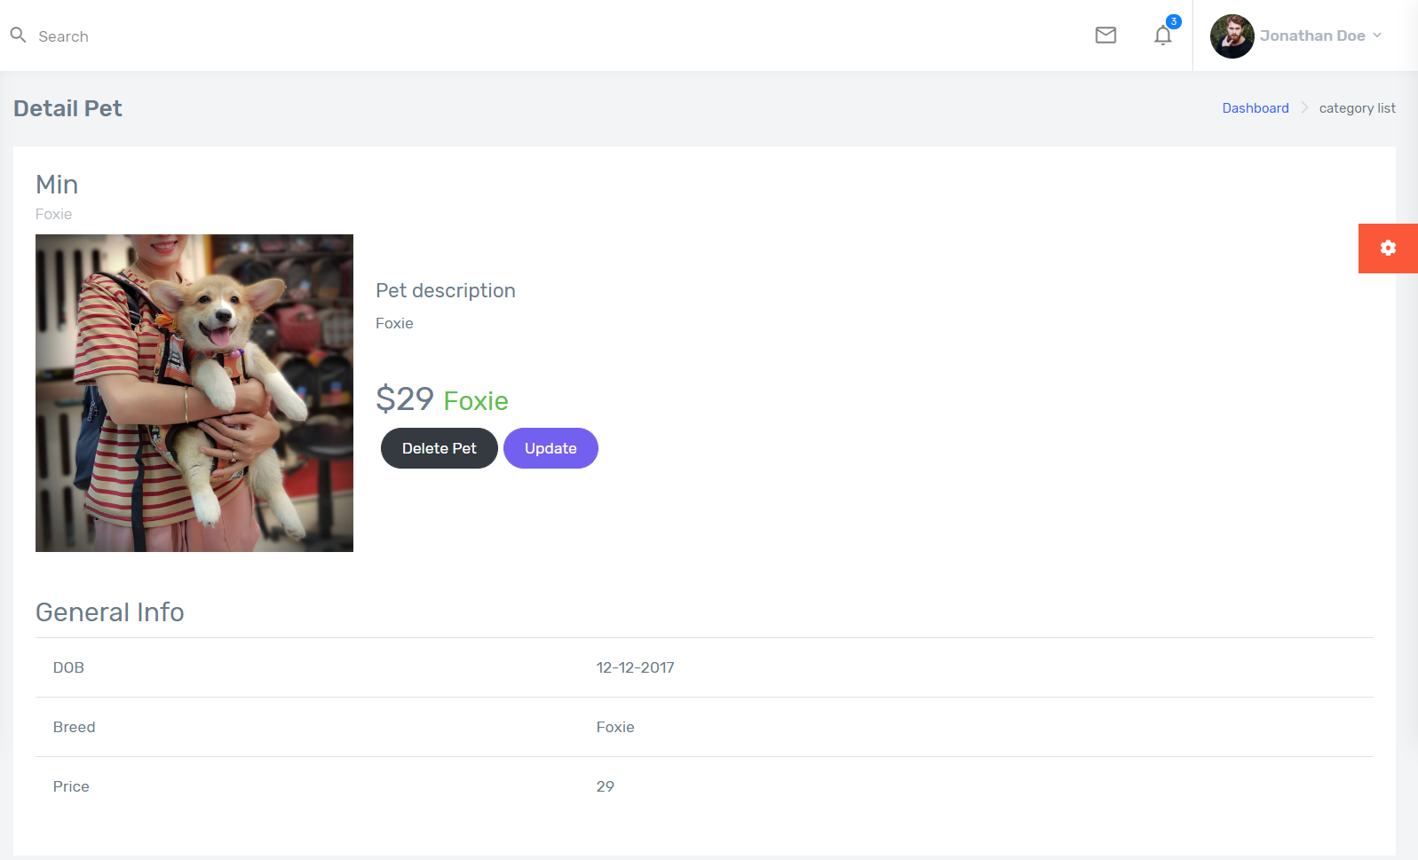***

|  |  |
| --- | --- |
| Description | Pet Detail |
| Connect From | Pet Page |
| Connect To | Pet Update, Pet Delete |
| Validation | N/A |
| Initial Values | Pet Details |
| Events | - when click “Update”, redirect to Update form  - when click “Delete Pet”, confirm page then delete product from database |

* + 1. ***Add Pet***

***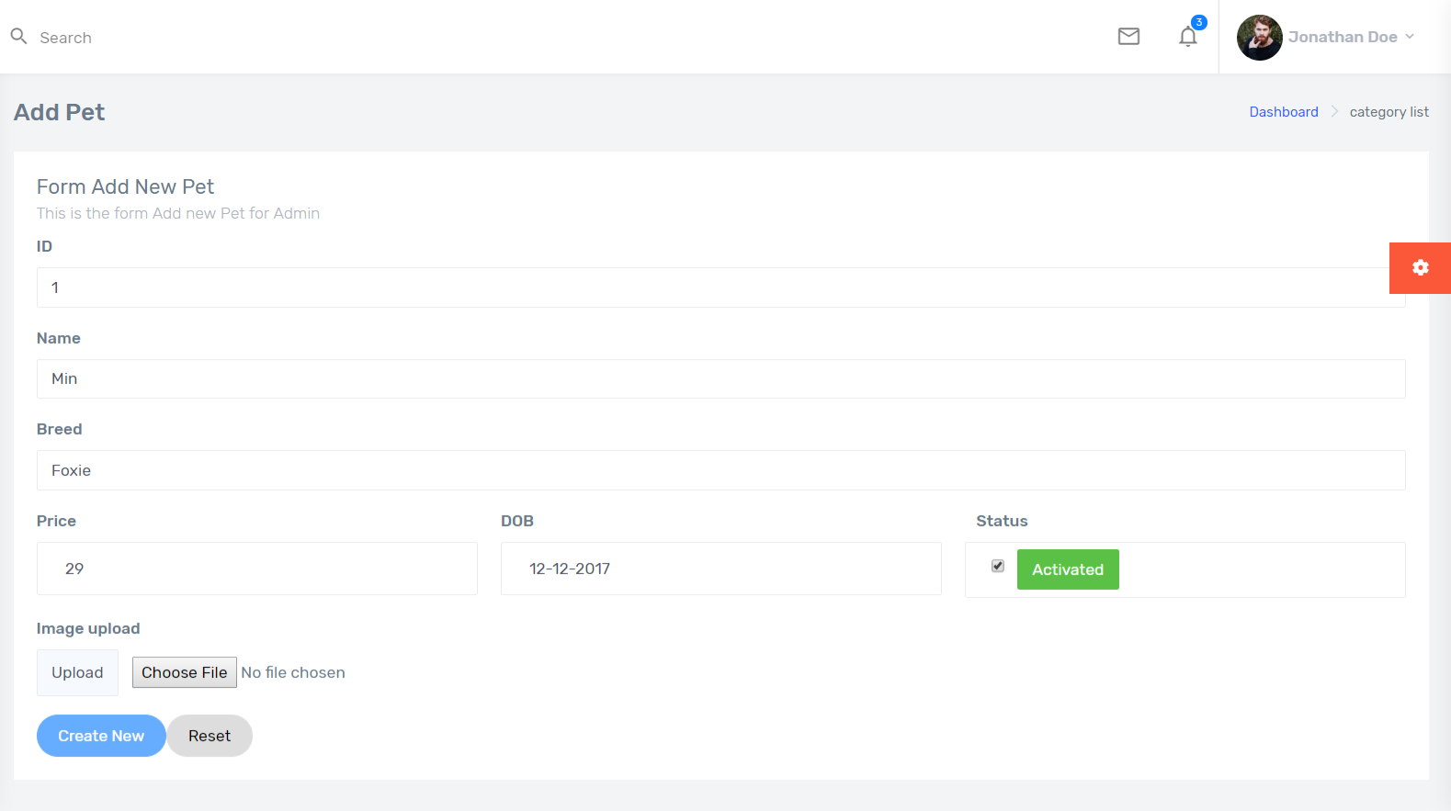***

|  |  |
| --- | --- |
| Description | Add new Pet |
| Connect From | Pet list page |
| Connect To | Product Detail |
| Validation | - All fields: not blank |
| Initial Values | N/A |
| Events | - When click “Create New”, add product in database  - When click “Reset”, reset all fields |

* + 1. ***Delete pet***

******

|  |  |
| --- | --- |
| Description | Pet Delete |
| Connect From | Pet Page |
| Connect To | Pet Update, Pet Delete |
| Validation | N/A |
| Initial Values | Pet Details |
| Events | - when click “Delete Pet”, confirm page then delete product from database |

* + 1. ***Update Pet***

***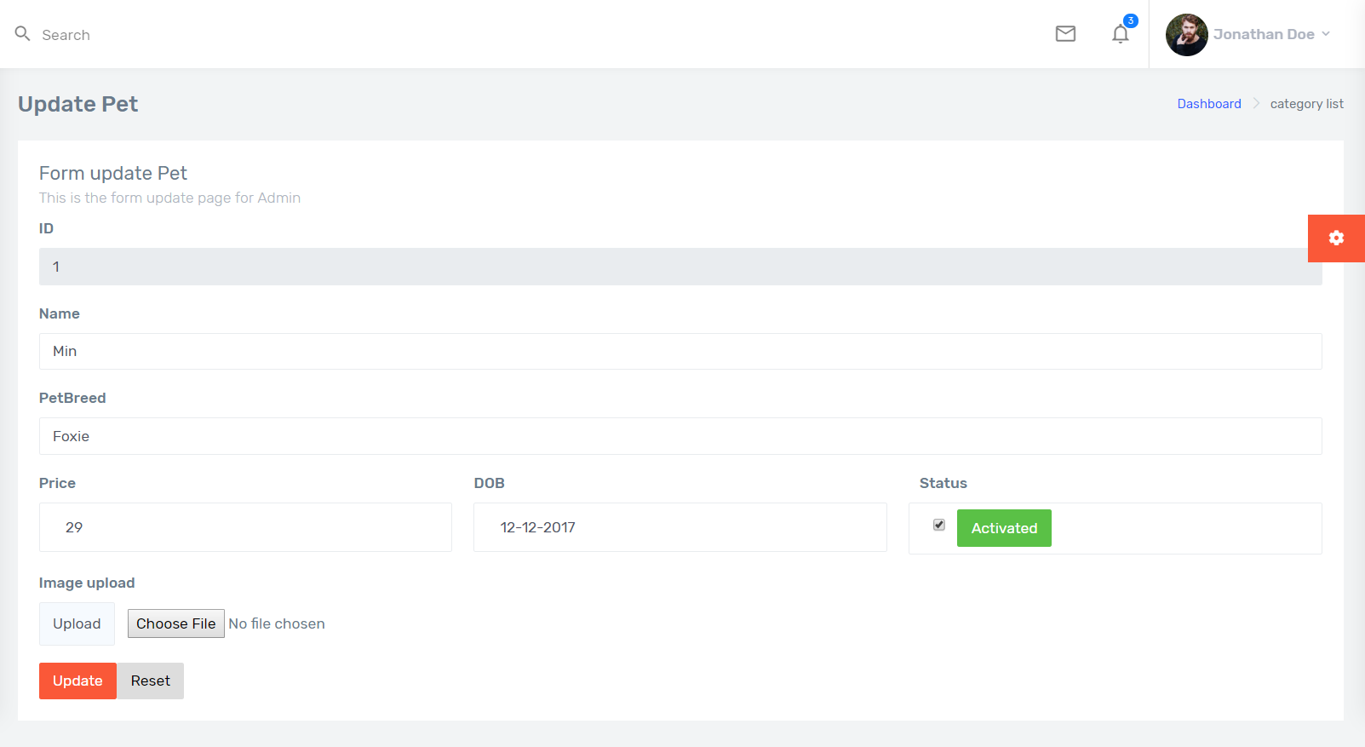***

|  |  |
| --- | --- |
| Description | Pet Update |
| Connect From | Pet Detail |
| Connect To | Pet Detail |
| Validation | - All fields: not blank |
| Initial Values | - Product Detail |
| Events | - When click “Update”, update product in database  - When click “Reset”, reset all fields |

REVIEW 3 – TASK SHEET

|  |  |  |  |  |  |
| --- | --- | --- | --- | --- | --- |
| **No.** | **Contents** | **Member** | **Activity Plan** | **Preparation** | |
| **Start Date** | **Actual Days** | **Status** |
| 1 | Client’s site map | Tran Tan Duy | 10/04/2019 | 15 | Completed |
| 2 | Admin’s site map | Tran Tan Duy |
| **Client** | | |
| 1 | Homepage | Le Cong Dat |
| 2 | Register | Le Cong Dat |
| 3 | Update user | Le Cong Dat |
| 4 | Login | Le Cong Dat |
| 5 | About us | Le Cong Dat |
| 6 | Dating List | Le Cong Dat |
| 7 | Pet Dating | Le Cong Dat |
| 8 | Pet List | Le Cong Dat |
| 9 | Pet Detail | Le Cong Dat |
| 10 | Pet Add | Le Cong Dat |
| 11 | Pet Update | Le Cong Dat |
| 12 | Pet Delete | Le Cong Dat |
| 13 | Gallery | Tran Thi Tuyet Duyen |
| 14 | Product | Tran Thi Tuyet Duyen |
| 15 | Product Details | Tran Thi Tuyet Duyen |
| 16 | Top Seller | Tran Thi Tuyet Duyen |
| 17 | Search and Filter Product | Tran Thi Tuyet Duyen |
| 18 | Cart Page | Tran Thi Tuyet Duyen |
| 19 | Appointment Form | Tran Tan Duy |
| 20 | Services | Tran Tan Duy |
| 21 | Service detail | Tran Tan Duy |
| **Admin** | |  |
| 1 | Admin Login | Le Cong Dat |
| 2 | Admin’s Dashboard | Tran Tan Duy |
| 3 | Category list | Tran Thi Tuyet Duyen |
| 4 | Category add | Tran Thi Tuyet Duyen |
| 5 | Category details | Tran Thi Tuyet Duyen |
| 6 | Category update | Tran Thi Tuyet Duyen |
| 7 | Category delete | Tran Thi Tuyet Duyen |
| 8 | Product list | Tran Thi Tuyet Duyen |
| 9 | Product details | Tran Thi Tuyet Duyen |
| 10 | Product add | Tran Thi Tuyet Duyen |
| 11 | Product update | Tran Thi Tuyet Duyen |
| 12 | Product delete | Tran Thi Tuyet Duyen |
| 13 | Service List | Tran Tan Duy |
| 14 | Service add | Tran Tan Duy |
| 15 | Service update | Tran Tan Duy |
| 16 | Service delete | Tran Tan Duy |
| 17 | List Pet | Le Cong Dat |
| 18 | Pet detail | Le Cong Dat |
| 19 | Pet Add | Le Cong Dat |
| 20 | Delete Pet | Le Cong Dat |
| 21 | Update Pet | Le Cong Dat |

Plan prepared by: Group 2 May 2st, 2019  
 **Group Leader Faculty**

**Tran Thi Tuyet Duyen Mr. Cat Nghiem Hieu Tuan**